

**MADRAS INSTITUTE OF TECHNOLOGY**

**ANNA UNIVERSITY**

**DEPARTMENT OF INFORMATION TECHNOLOGY**

**IT5312 – DATA ANALYTICS AND CLOUD COMPUTING**

**LAB MANUAL**

**Vision of the Department**

To educate students with conceptual knowledge and technical skills in the field of Information Technology with moral and ethical values to achieve excellence in an academic, industry and research centric environment.

**Mission of the Department**

1. To inculcate in students a firm foundation in theory and practice of IT skills coupled with the thought process for disruptive innovation and research methodologies, to keep pace with emerging technologies.
2. To provide a conducive environment for all academic, administrative, and interdisciplinary research activities using state-of-the-art technologies.
3. To stimulate the growth of graduates and doctorates, who will enter the workforce as productive IT engineers, researchers, and entrepreneurs with necessary soft skills, and continue higher professional education with competence in the global market.
4. To enable seamless collaboration with the IT industry and Government for consultancy and sponsored research.
5. To cater to cross-cultural, multinational, and demographic diversity of students.
6. To educate the students on the social, ethical, and moral values needed to make significant contributions to society.

**Program Educational Objectives (PEOs)**

**PEO1:** Demonstrate core competence in basic engineering and mathematics to design, formulate, analyze, and solve hardware/software engineering problems.

**PEO2:** Develop insights in foundational areas of Information Technology and related engineering to address real-world problems using digital and cognitive technologies.

**PEO3:** Collaborate with industry, academic and research institutions for state-of-the-art product development and research.

**PEO4:** Inculcate a high degree of professionalism, effective communication skills and team spirit to work on multidisciplinary projects in diverse environments.

**PEO5:** Practice high ethical values and technical standards.

**Program Specific Outcomes (PSOs):**

**PSO1:** Ability to apply programming principles and practices for the design of software solutions in an internet-enabled world of business and social activities.

**PSO2:**Ability to identify the resources to build and manage the IT infrastructure using the current technologies in order to solve real world problems with an understanding of the tradeoffs involved in the design choices.

**PSO3:** Ability to plan, design and execute projects for the development of intelligent systems with a focus on the future.

**IT5612 DATA ANALYTICS AND CLOUD COMPUTING LABORATORY L T P C**

1. **0 4 2**

**OBJECTIVES:**

To provide hands-on experience to cloud and data analytics frameworks and tools.

To use the Python packages for performing analytics.

To learn using analytical tools for real world problems.

To familiarize the usage of distributed frameworks for handling voluminous data.

To write and deploy analytical algorithms as MapReduce tasks.

**LABORATORY EXERCISES:**

Analytics Using Python:

1. Download, install and explore the features of NumPy, SciPy, Jupyter, Statsmodels

and Pandas packages.

(i) Reading data from text file, Excel and the web.

(ii) Exploring various commands for doing descriptive analytics on Iris data set.

2. Use the diabetes data set from UCI and Pima Indians Diabetes data set for

performing the following:

(i) Univariate analysis: Frequency, Mean, Median, Mode, Variance, Standard

Deviation, Skewness and Kurtosis.

(ii) Bivariate analysis: Linear and logistic regression modeling

(iii) Multiple Regression analysis

Also compare the results of the above analysis for the two data sets.

3. Apply Bayesian and SVM techniques on Iris and Diabetes data set.

4. Apply and explore various plotting functions on UCI data sets.

Cloud Computing:

5. Installation of OpenStack.

6. Creation of VMs and installing applications and executing simple programs in

OpenStack.

7. Simple applications for communication across VMs.

Hadoop, MapReduce, HDFS, Hive:

8. Install and configure Hadoop in its two operating modes: Pseudo distributed and fully

distributed.

9. Implement the following file management tasks in Hadoop: Adding files and

directories, retrieving files and deleting files.

10. Create a retail database with the following tables: Product, Customer, Manufacturer,

Shipping and Time using MongoDB and perform data replication using sharding

techniques.

11. Install HIVE and implement the above retail schema definition and perform CRUD

operations.

**OUTCOMES:**

On completion of the course, the students will be able to:

CO1: Install analytical tools and configure distributed file system.

CO2: Have skills in developing and executing analytical procedures in various distributed

frameworks and databases.

CO3: Develop, implement and deploy simple applications on very large datasets.

CO4: Implement simple to complex data modeling in NoSQL databases.

CO5: Develop and deploy simple applications in OpenStack cloud.

CO6: Implement real world applications by using suitable analytical framework and tools.

**Mapping of Course Outcomes (COs) with Program Outcomes (POs)**

|  |  |  |  |  |  |  |  |  |  |  |  |  |
| --- | --- | --- | --- | --- | --- | --- | --- | --- | --- | --- | --- | --- |
| **Course Outcomes (COs)** | **Program Outcomes (POs)** | | | | | | | | | | | |
| 1 | 2 | 3 | 4 | 5 | 6 | 7 | 8 | 9 | 10 | 11 | 12 |
| Install analytical tools and configure distributed file system | ✓ | ✓ | ✓ | ✓ |  |  |  |  | ✓ |  | ✓ | ✓ |
| Have skills in developing and executing analytical procedures in various distributed frameworks  and databases | ✓ | ✓ | ✓ | ✓ | ✓ |  |  |  | ✓ |  | ✓ | ✓ |
| Develop, implement and deploy simple applications on very large datasets. | ✓ | ✓ | ✓ | ✓ | ✓ |  |  |  | ✓ |  | ✓ | ✓ |
| Implement simple to complex  data modeling in NoSQL databases. | ✓ | ✓ | ✓ |  | ✓ |  |  |  | ✓ |  |  |  |
| Develop and deploy simple applications in OpenStack cloud | ✓ | ✓ | ✓ | ✓ |  |  |  |  | ✓ |  |  |  |
| Implement real world applications by using suitable analytical framework and tools | ✓ | ✓ | ✓ | ✓ | ✓ |  |  |  |  |  | ✓ | ✓ |

|  |  |
| --- | --- |
| **SNO** | **NAME OF EXPERIMENT** |
| 1. | Identification and reading of the dataset |
| 2. a | Descriptive Analysis |
| 2. b | Univariate Analysis |
| 2. c | Bivariate Analysis |
| 2. d | Multivariate Analysis |
| 3. a | Logistic Regression |
| 3. b | Multiple Regression |
| 4. | Classification using Naïve bayes classifier and Support Vector Machine |
| 5 a. | Open stack |
| 5 b. | Open Stack Installation |
| 5 c. | Creation of VMs in Open Stack |
| 6 a. | Hadoop Installation |
| 6 b. | Hadoop File Implementation |
| 7 a. | Hive Installation |
| 7 b. | Hive - CRUD operations |
| 8 a. | MongoDB basics |
| 8 b. | MongoDB Data replication |
| 9. | Visualisation tool in python |

**Exp no : 0**

**Study on Numpy,Scipy, Statmodels and Pandas Packages**

**Aim:**  To study about the Python packages required to work with data analytics

**Theory:**

**a. Pandas**

Pandas is an open-source library that is made mainly for working with relational and

labelled data. It provides various data structures and operations for manipulating data.

Functions in Pandas

|  |  |  |
| --- | --- | --- |
| **SNO** | **DESCRIPTION** | **EXAMPLE** |
|  | read_csv( ) : This helps to read a csv [comma separated-values] file into a pandas dataframe. It can also read files separated by delimiter | data_e = pd.read_csv (r‘c:user_ds.csv’) |
|  | head( ) : The head(n) is used to return the first n rows of a dataset. By default, the function returns 5 rows of the dataframe | data_e.head(10) |
|  | describe( ) : It is used to generate descriptive statistics of data in a pandas data frame or services | data_e.describe( ) |
|  | memory_usage( ) : It returns a pandas series having the memory usage of each column in a dataframe | data_e.memory_usage(deep = = true) |
|  | loc[ ] : It helps to access a group of rows and columns in a dataset | data_e.loc[0:4, [‘Name’, ‘Age’, ‘State’] ] |

**b. Numpy**

Numpy is a Python library used for working with arrays. It also has functions for

working in domain of linear algebra, Fourier transformation and matrices.

|  |  |  |
| --- | --- | --- |
| **SNO** | **DESCRIPTION** | **EXAMPLE** |
|  | numpyreshape : This function allows us to change the dimension of the array without hampering the data value | res = arr.reshape(3, 2) |
|  | numpy.concatenate( ) : This function is used to join two arrays of same size, either in a row-wise or column-wise way | res = numpy.concatenate( (arr1, arr2), axis =1) |
|  | numpy.char.add( ) : It concatenates the data value of two arrays, merge them and represent a new array as a result | res = numpy.concatenate( (arr1, arr2), axis =1) |
|  | numpy.median( ) : It calculates the median of an ordered array | med = numpy.median(X) |
|  | numpy.average( ) : It returns the average of all data values of the passed array | avg = numpy.average(X) |

**c. Scipy**

Scipy contains a variety of sub packages which help to solve the most common issue

related to scientific computation. It is built on top of the numpy library.

|  |  |  |
| --- | --- | --- |
| **SNO** | **DESCRIPTION** | **EXAMPLE** |
|  | special.logsumexp(x) : log sum exponential computes the log of sum exponential input element | np.log( np.sum ( np.exp(a))) |
|  | linalg.det : linear algebra of scipy is an implementation of BLAS and ALAS LAPACK libraries. It accepts 2D arrays and gives a @D array | ar = np.array([4, 5], [5, 2]) linalg.det(ar) |
|  | linalg.eig( ) : The most common problem in linear algebra is Eigen value and Eigen value | eg_val, eg_vec = linalg.eig(ar) |
|  | Scipy.sparse : It is used for creating sparse matrix using multiple data structures | from scipy.sparse import csr_matrixar = np.array( [0, 0], [1, 1]) print(csr_matrix(ar).data) |

**d. Stats Model**

It provides classes and functions for the estimation of many different statistical models

for conducting statistical test and statistical data exploration.

Functions in Scipy

|  |  |  |
| --- | --- | --- |
| **SNO** | **DESCRIPTION** | **EXAMPLE** |
|  | get_rdataset : It is used to download any dataset we want | data = sm.datasets. get_rdataset(“Guerry”, “Hist”).data |
|  | add_constant(X) : It is used to add a constant column to input dataset | X = sm.addconstant(X) |
|  | OLS(y, x).fit( ) : It is a type of linear square method for estimating unknown parameters in linear regression | res = sm.OLS(y, x).fit( ) |
|  | linear_rainbow( ) : The null hypothesis is the fit of the model using full sample. It is the same as using a central subset. Rainbow test has power against many different forms of non-linearity | print(sm.stats.linear_rainbow.— doc--) |

**Result:**

Thus, a study on the Python packages used to work with data analysis has been made.

**Exp. No.:** 1

**Identification and reading of the dataset**

**Aim:** To write python programs to read and display content from text file, csv file and web.

**About the dataset:**

IOT based sensor system is used to detect and capture the weather and surrounding environment. Contains Humidity, Temperature, Light, Co2, Humidity Ratio, Occupancy and Date columns. These are fed into the algo to detect anomalies.

**CODES AND OUTPUTS:**

1. **Reading from Text File**

Code:

lines = [ ]

with open("/content/datatest.txt") as f:

  lines = f.readlines()

count = 0

for line in lines:

  count += 1

  print(f'line {count}: {line}')

Output

line 167: "305","2015-02-02 17:04:00",22.6,25,433,832,0.00423823118799312,1

line 168: "306","2015-02-02 17:05:00",22.6,25,433,836.25,0.00423823118799312,1

line 169: "307","2015-02-02 17:06:00",22.6,25,428.2,832.6,0.00423823118799312,1

line 174: "312","2015-02-02 17:10:59",22.58,25.08,433,821.5,0.00424669048857924,1

1. **Reading as a csv file (reading the text file into a dataframe)**

Code:

df=pd.read_csv("/content/datatest.txt",encoding="UTF-8")

df

Output

**date Temperature Humidity Light CO2 HumidityRatio Occupancy**

|  |  |  |  |  |  |  |  |
| --- | --- | --- | --- | --- | --- | --- | --- |
| **140** | 2015-02-02 14:19:00 | 23.7000 | 26.272 | 585.200000 | 749.200000 | 0.004764 | 1 |
| **141** | 2015-02-02 14:19:59 | 23.7180 | 26.290 | 578.400000 | 760.400000 | 0.004773 | 1 |
| **142** | 2015-02-02 14:21:00 | 23.7300 | 26.230 | 572.666667 | 769.666667 | 0.004765 | 1 |
|  |  |  |  |  |  |  |  |
| **143** | 2015-02-02 14:19:00 | 23.7000 | 26.272 | 585.200000 | 749.200000 | 0.004764 | 1 |
| **144** | 2015-02-02 14:19:59 | 23.7180 | 26.290 | 578.400000 | 760.400000 | 0.004773 | 1 |
| **145** | 2015-02-02 14:21:00 | 23.7300 | 26.230 | 572.666667 | 769.666667 | 0.004765 | 1 |



1. **Reading from Web**

Code:

import requests

from bs4 import BeautifulSoup

r = requests.get("https://www.mitindia.edu/en/")

soup = BeautifulSoup (r.content, 'html.parser')

lines = soup.find_all('p')

for line in lines: print(line.text)

Output

In 1949,Shri.C.Rajam, gave the newly independent India-Madras Institute of Technology, so that MIT could establish the strong technical base it needed to take its place in the world. It was the rare genius and daring of its founder that made MIT offer courses like Aeronautical Engineering, Automobile Engineering, Electronics Engineering and Instrument Technology for the first time in our country. Now it also provides technical education in other engineering fields such as Rubber and Plastic Technology & Production Technology. It was merged with Anna University in the year 1978. Sixty years hence, while it continues to be a pioneer in courses that it gave birth to, it is already renowned

…………….



**Result:**

Thus, the Python programs to read and display content from text file, CSV file, and web

have been written and verified.

**Exp no :2 a**

**Descriptive Analysis**

**Aim:** to explore various commands for performing descriptive data analysis on the dataset

**CODES AND OUTPUTS:**

Importing the dataset and the packages necessary

import pandas as pd

df=pd.read_csv("/content/datatest.txt",encoding="UTF-8")

1. Head ()

df.head()

**OUTPUT**

**date Temperature Humidity Light CO2 HumidityRatio Occupancy**

|  |  |  |  |  |  |  |  |
| --- | --- | --- | --- | --- | --- | --- | --- |
| **140** | 2015-02-02 14:19:00 | 23.7000 | 26.272 | 585.200000 | 749.200000 | 0.004764 | 1 |
| **141** | 2015-02-02 14:19:59 | 23.7180 | 26.290 | 578.400000 | 760.400000 | 0.004773 | 1 |
| **142** | 2015-02-02 14:21:00 | 23.7300 | 26.230 | 572.666667 | 769.666667 | 0.004765 | 1 |
|  |  |  |  |  |  |  |  |
| **143** | 2015-02-02 14:19:00 | 23.7000 | 26.272 | 585.200000 | 749.200000 | 0.004764 | 1 |
| **144** | 2015-02-02 14:19:59 | 23.7180 | 26.290 | 578.400000 | 760.400000 | 0.004773 | 1 |

1. Columns

Df.columns

**OUTPUT**

Index(['date', 'Temperature', 'Humidity', 'Light', 'CO2', 'HumidityRatio', 'Occupancy'], dtype='object')

1. Isnull()

newdf = df.isnull().sum()

print(newdf.to_string())

**OUTPUT**

date 0

Temperature 0

Humidity 0

Light 0

CO2 0

HumidityRatio 0

Occupancy 0

1. shape

df.shape()

**OUTPUT**

(2665,7)

1. dtypes

df.dtypes

**OUTPUT**

date object

Temperature float64

Humidity float64

Light float64

CO2 float64

HumidityRatio float64

Occupancy int64

dtype: object

1. value_count

df.value_counts("Humidity")

**OUTPUT**

Humidity

22.500000 93

25.000000 82

22.290000 63

22.200000 62

22.700000 51

..

26.080000 1

26.059167 1

26.050000 1

26.020000 1

31.472500 1

Length: 725, dtype: int64

1. drop_duplicates

data = df.drop_duplicates(subset ="Humidity",)

**OUTPUT**

| **date** | **Temperature** | **Humidity** | **Light** | **CO2** | **HumidityRatio** | **Occupancy** |
| --- | --- | --- | --- | --- | --- | --- |
| **140** | 2015-02-02 14:19:00 | 23.700000 | 26.272000 | 585.200000 | 749.200000 | 0.004764 | 1 |
| **141** | 2015-02-02 14:19:59 | 23.718000 | 26.290000 | 578.400000 | 760.400000 | 0.004773 | 1 |
| **142** | 2015-02-02 14:21:00 | 23.730000 | 26.230000 | 572.666667 | 769.666667 | 0.004765 | 1 |
| **...** | ... | ... | ... | ... | ... | ... | ... |
| **2798** | 2015-02-04 10:37:00 | 24.290000 | 25.978000 | 793.000000 | 1145.400000 | 0.004882 | 1 |
| **2799** | 2015-02-04 10:38:00 | 24.290000 | 25.852000 | 801.400000 | 1140.800000 | 0.004858 | 1 |
| **2804** | 2015-02-04 10:43:00 | 24.408333 | 25.681667 | 798.000000 | 1124.000000 | 0.004860 | 1 |

725 rows × 7 columns

1. Mean, median and mode

df['Humidity'].mean()

df['Humidity'].median()

df['Humidity'].mode()

**OUTPUT:**

Mean: 25.353936799785583]

Median: 25.0

Mode: 0 22.5 dtype: float64

1. Describe

df.describe()

**OUTPUT**

Temperature Humidity Light CO2 HumidityRatio Occupancy

count 2665.000000 2665.000000 2665.000000 2665.000000 2665.000000 2665.000000

mean 21.433876 25.353937 193.227556 717.906470 0.004027 0.364728

std 1.028024 2.436842 250.210906 292.681718 0.000611 0.481444

min 20.200000 22.100000 0.000000 427.500000 0.003303 0.000000

25% 20.650000 23.260000 0.000000 466.000000 0.003529 0.000000

50% 20.890000 25.000000 0.000000 580.500000 0.003815 0.000000

75% 22.356667 26.856667 442.500000 956.333333 0.004532 1.000000

max 24.408333 31.472500 1697.250000 1402.250000 0.005378 1.000000

1. Info

df.info()

**OUTPUT:**

<class 'pandas.core.frame.DataFrame'>

Int64Index: 2665 entries, 140 to 2804

Data columns (total 7 columns):

# Column Non-Null Count Dtype

--- ------ -------------- -----

0 date 2665 non-null object

1 Temperature 2665 non-null float64

2 Humidity 2665 non-null float64

3 Light 2665 non-null float64

4 CO2 2665 non-null float64

5 HumidityRatio 2665 non-null float64

6 Occupancy 2665 non-null int64

dtypes: float64(5), int64(1), object(1)

memory usage: 166.6+ KB



**Result:**

Thus, the Python programs to perform descriptive analysis has been implemented successfully.



**Exp no :2 b**

**Univariate Analysis**

**Aim:** to explore various commands for performing univariate data analysis on the dataset

1. Var() and std()

df[“Humidtiy”].var()

df[“Humidtiy”].var()

**OUTPUT**

5.9382005

2.4368423

1. Skew()

From scipysats import skew

y1=df[“Humidity”]

print(“Skewness: “ , skew(y1))

OUTPUT

Skewness = 0.67238354

Importing seaborn and matplotlib

import seaborn as sns

import matplotlib.pyplot as plt

1. Histplot

sns.histplot(x="Temperature", data=df)

**OUTPUT**

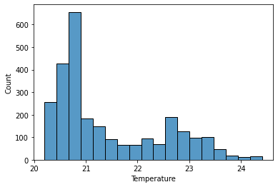

1. Kdeplot

sns.kdeplot(x="Temperature", data=df)

**OUTPUT**

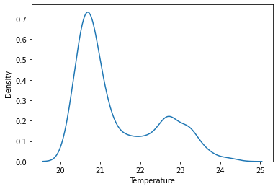

1. Histplot() along with kdeplot

sns.histplot(x="Temperature", data=df, kde=True)

**OUTPUT**

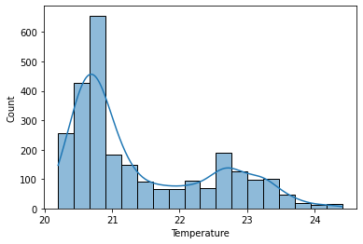

1. Boxplot

sns.boxplot(x=df["Temperature"])

**OUTPUT**

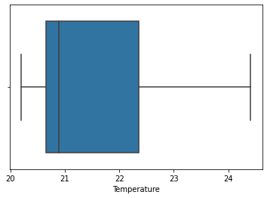

1. Countplot

sns.countplot(x=df.head(10)["Temperature"])

**OUTPUT**

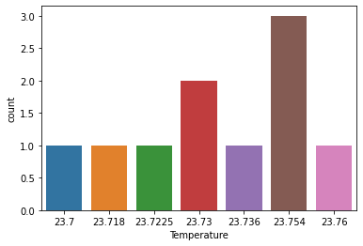

1. Stripplot

sns.stripplot(x=df["Temperature"])

**OUTPUT**

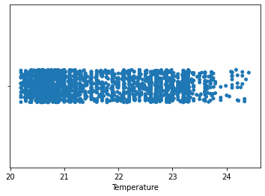



**Result:**

Thus, the Python programs to perform univariate analysis has been implemented successfully.



**Exp no :2 c**

**Bivariate Analysis**

**Aim:** to explore various commands for performing bivariate data analysis on the dataset

1. Lineplot

plt.plot(df.head(10)["Temperature"], df.head(10)["Humidity"])

plt.show()

**OUTPUT**

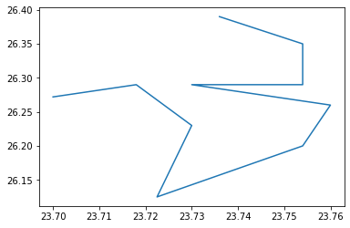

1. Scatter plot

plt.scatter(df.head(20)["Temperature"], df.head(20)["Humidity"])

plt.show()

**OUTPUT**

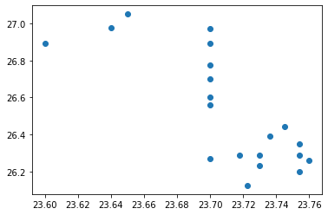

1. Bar

fig = plt.figure(figsize = (20, 5))

plt.bar(df.head(6)["date"], df.head(6)["Humidity"], color ='maroon',width = 0.4)

plt.xlabel("DATE")

plt.ylabel("HUMIDITY")

plt.show()

**OUTPUT**

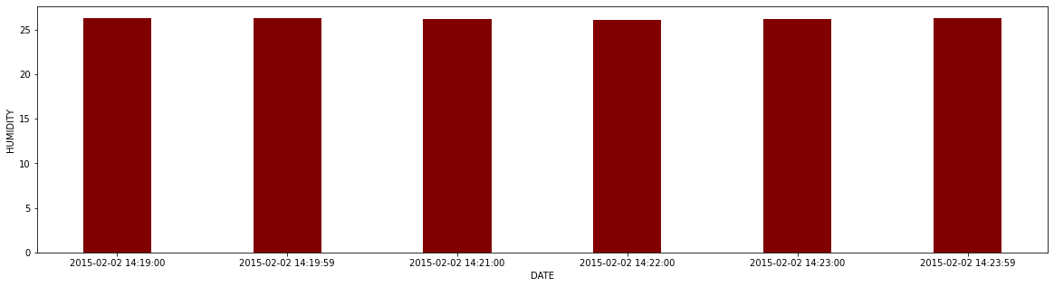



**Result:**

Thus, the Python programs to perform univariate analysis has been implemented successfully.



**Exp no :2 c**

**Multivariate Analysis**

**Aim:** to explore various commands for performing bivariate data analysis on the dataset

1. Clustering analysis

First we find the number of cluster using the elbow graph and then cluster the data

from sklearn.cluster import KMeans

from scipy.spatial.distance import cdist

K = range(1,10)

distortions = []

interias = []

df1=df.drop(df.columns[[0]], axis=1)

for k in K:

  kmeans = KMeans(n_clusters=k).fit(df1)

  kmeans.fit(df1)

  distortions.append(sum(np.min(cdist(df1, kmeans.cluster_centers_, 'euclidean'), axis=1)))

  interias.append(kmeans.inertia_)

plt.plot(K, distortions, 'bx-')

plt.xlabel('Number of Clusters', fontsize=13)

plt.ylabel('Distortion or SSE', fontsize=13)

plt.title('SSE vs Number of Clusters - Elbow Plot', fontsize=13)

plt.show()

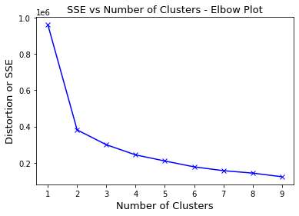

=kmeans = KMeans(n_clusters = 3)

kmeans.fit(df1)

df1['clusters'] = kmeans.fit_predict(df1)

plt.scatter(df1['Temperature'], df1['Light'], c=df1['clusters'], cmap='rainbow')

plt.xlabel("T", fontsize=13)

plt.ylabel("L", fontsize=13)

plt.show()

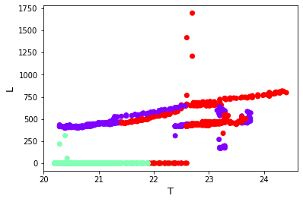

1. MULTIVARIATE ANALYSIS: PCA

from sklearn.decomposition import PCA

pca = PCA()

feature = pca.fit_transform(feature.drop("date", axis="columns"))

variance = pca.explained_variance_ratio_

print(variance*100)

PC_Values = np.arange(pca.n_components_) + 1

plt.plot(PC_Values, pca.explained_variance_ratio_, 'o-', linewidth=2, color='blue')

plt.axhline(y=0.023, color='r', linestyle='-')

plt.title("Scree Plot", fontsize=15)

plt.xlabel('Principal Component', fontsize=14)

plt.ylabel('Variance Explained', fontsize=14)

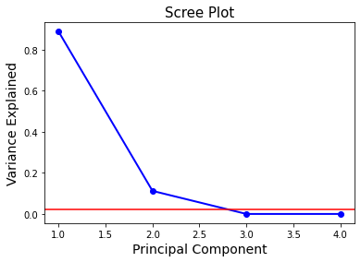

1. Pairplot

import seaborn as sns

import matplotlib.pyplot as plt

sns.pairplot(df.drop(["date",],axis=1).head(100),height=3)

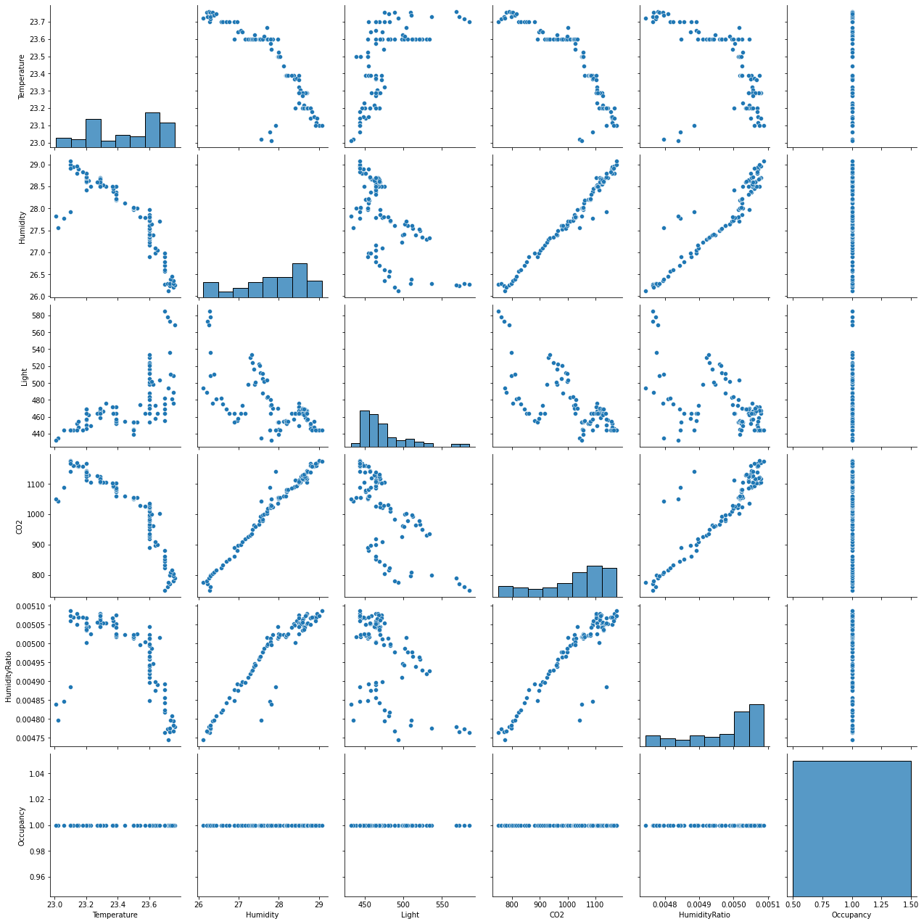



**Result:**

Thus, the Python programs to perform multivariate analysis has been implemented successfully.



**Exp no :3 a**

**Logistic Regression**

**Aim:** To explore various commands for performing Logistic regression on the dataset

df=pd.read_csv("/content/datatest.txt",encoding="UTF-8") //reading train data

df1=pd.read_csv("/content/datatest2.txt",encoding="UTF-8")//reading test data

y1=df["Occupancy"]

x1=df.drop(["Occupancy","date",],axis=1) // splitting into input and output

y=df["Occupancy"]

x=df.drop(["Occupancy","date",],axis=1) // splitting into input and output

// training the logistic regression model

from sklearn.linear_model import LogisticRegression

lr = LogisticRegression()

lr.fit(x1,y1)

predictions = lr.predict(x) //making predictions

score = lr.score(x, y)

print(score) //printing the accuracy score

// heatmap

from sklearn import metrics

plt.figure(figsize=(9,9))

sns.heatmap(cm, annot=True, fmt=".3f", linewidths=.5, square = True, cmap = 'Blues_r');

plt.ylabel('Actual label');

plt.xlabel('Predicted label');

all_sample_title = 'Accuracy Score: {0}'.format(score)

plt.title(all_sample_title, size = 15);

**OUTPUT**

Score =0.9786116322701689

Confusion matrix

[[1639 54]

[ 3 969]]

Heat map

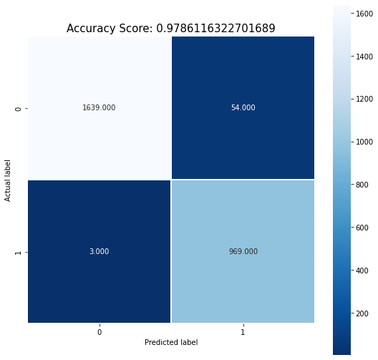



**Result:**

Thus, the Python programs to perform Logistic regression has been implemented successfully.



**Exp no :3 b**

**Multiple Regression**

**Aim:** to explore various commands for performing multiple regression on the dataset

from sklearn.linear_model import LinearRegression

x1=df.drop(["Occupancy","date","HumidityRatio",],axis=1)

y1=df["HumidityRatio"]

//splitting the data into input and predicted data

x=df.drop(["Occupancy","date","HumidityRatio",],axis=1)

y=df["HumidityRatio"]

//training the model and predicting values

linearReg = LinearRegression()

linearReg.fit(x1,y1)

y_pred=linearReg.predict(x)

//accuracy of the model

score = linearReg.score(x, y)

print(score)

**OUTPUT**

prediction: array([0.00473046, 0.00473909, 0.00473404, ..., 0.00483148, 0.00483807, 0.00484892])

Intercept: -0.005338032822997117

Coefficients: [ 2.52716004e-04 1.53192296e-04 -3.30661947e-08 9.85101138e-08]

Score: 0.9987793863852992



**Result:**

Thus, the Python programs to perform Multiple regression has been implemented successfully. 

**Exp no :4 a**

**Classification using Naïve Bayes Classifier**

**Aim:** to explore commands for performing classification using naïve bayes classifier on the

Dataset

// reading the test and train data

dfTrain = pd.read_csv('/datatraining.txt')

dfTest = pd.read_csv('/datatest.txt')

y_train = dfTrain["Occupancy"]

x_train = dfTrain.drop(["Occupancy", "date", ], axis = 1)

y_test = dfTest["Occupancy"]

x_test = dfTest.drop(["Occupancy", "date", ], axis = 1)

// training and predicting

from sklearn.preprocessing import StandardScaler

sc = StandardScaler() //standard scaling

x_train = sc.fit_transform(x_train)

x_test = sc.transform(x_test)

from sklearn.naive_bayes import GaussianNB

classifier = GaussianNB()

classifier.fit(x_train, y_train)

y_pred = classifier.predict(x_test)

y_pred

//heatmap

score = classifier.score(x_test, y_test)

plt.figure(figsize=(9,9))

sns.heatmap(cm, annot=True, fmt=".3f", linewidths=.5, square = True, cmap = 'Blues_r');

plt.ylabel('Actual label');

plt.xlabel('Predicted label');

all_sample_title = 'Accuracy Score: {0}'.format(score)

plt.title(all_sample_title, size = 15);

**OUTPUT**

//predicted value

array([1, 1, 1, ..., 1, 1, 1])

//confusion matrix

[[1638 55]

[ 5 967]]

//accuracy score

0.9774859287054409

Heatmap

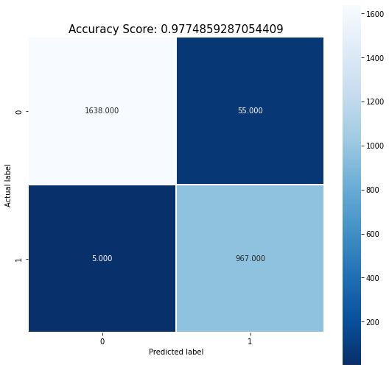



**Result:**

Thus, the Python programs to perform classification using Naïve Bayes classifier has been implemented successfully.



**Exp no :4 b**

**Classification using support vector machine**

**Aim :** to explore commands for performing classification using support vector machine on the dataset

// reading the test and train data

dfTrain = pd.read_csv('/datatraining.txt')

dfTest = pd.read_csv('/datatest.txt')

y_train = dfTrain["Occupancy"]

x_train = dfTrain.drop(["Occupancy", "date", ], axis = 1)

y_test = dfTest["Occupancy"]

x_test = dfTest.drop(["Occupancy", "date", ], axis = 1)

// training and predicting

from sklearn.svm import SVC

clf = SVC(kernel='rbf')

clf.fit(x_train, y_train)

y_pred=clf.predict(x_test)

y_pred

from sklearn import metrics

print(metrics.classification_report(y_test.astype('float32'), y_pred))

//heatmap

plt.figure(figsize=(9,9))

sns.heatmap(cm, annot=True, fmt=".3f", linewidths=.5, square = True, cmap = 'Blues_r');

plt.ylabel('Actual label');

plt.xlabel('Predicted label');

all_sample_title = 'Accuracy Score: {0}'.format(score)

plt.title(all_sample_title, size = 15);

**OUTPUT**

//predicted value

array([1, 1, 1, ..., 1, 1, 1])

//performance metrics

precision recall f1-score support

0.0 1.00 0.95 0.98 1693

1.0 0.93 1.00 0.96 972

accuracy 0.97 2665

macro avg 0.96 0.98 0.97 2665

weighted avg 0.97 0.97 0.97 2665

Heatmap

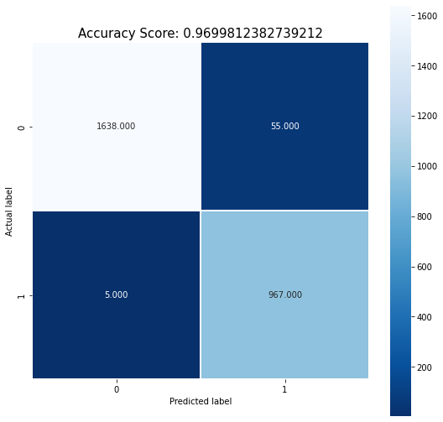

**Result:**

Thus, the Python programs to perform classification using Support Vector Machine has been implemented successfully.



**Exp no :5 a**

**OpenStack**

**Aim:**

To understand OpenStack deployment, its implementation and its applications.

**Theory:**

OpenStack is a cloud operating system that controls large pools of compute, storage and networking resources throughout a data-centre, all managed and provisioned through APIs with common authentication mechanisms. A dashboard is also available, giving administrators control while empowering their users to provide resources through a web interface. It began in 2010 as a joint project of Ra despace hosting and NASA. It was managed by the OpenStack Foundation, a non-profit entity.

**Working of OpenStack**

It is essentially a series of commands known as scripts. These scripts are bundled into packages called projects that relay tasks that create cloud environments. To create these environments, OpenStack relies on

- Virtualization that creates a layer of virtual resources abstracted from hardware

- A base as that carries out commands given by OpenStack scripts

OpenStack uses virtualized resources to build clouds. It doesn’t execute commands, rather delays them to base OS.

**Components of OpenStack**

OpenStack’s architecture is made up of numerous open source projects. These are used to set up OpenStack’s undercloud and overcloud. Overcloud is used by cloud users and undercloud is used by system admins. Underclouds contain the core components system admins need to set up and manage end user’s environments called overclouds.

There are 6 stable, core services that handle computing, networking, storage, identity and images. These make up the infrastructure of OpenStack that allows the rest of the projects to handle dashboarding, orchestration, etc.

The 6 components are:

- Nova: It is a full management tool that helps compute resource-handling, scheduling, creation, deletion, etc.

- Neutron: It connects the networks across other services

- Swift: It is a highly fault-tolerant object storage service that stores and retrieves

unstructured data objects

- Cinder: Provides persistent block storage

- Keystone: Authenticates and authorises all services

- Glance: Stores and retrieves VM disc images from various locations

**Deployment of OpenStack**

It is mostly deployed as infrastructure-as-a-Service (IaaS) in both public and private

clouds where virtual servers and other resources are made available to users. The software

platform consists of interrelated components control diverse, multivendor hardware. Lifecycle

management tools and packaging are used to help instances maintain the lifecycle of

deployments. Frameworks for the above are Tripleo, OpenStack-helm, kolla-ansible, kayole,

etc.

**Challenges in Implementation**

* Installation challenges
* Documentation
* Upgrading OpenStack
* Long Term Support
* Deployment Models
* OpenStack-based public cloud
* On-premises distribution
* Hosted OpenStack Private Cloud
* Appliance based OpenStack
* Applications of OpenStack
* Private clouds and Public clouds
* Network function virtualization
* Containers



**Result:**

Thus, OpenStack deployment, its implementation and its applications have been

studied.

**Exp no :5 b**

**OpenStack Installation**

**Aim:**

To install OpenStack and implement Infrastructure-as-a-service using it.

**Procedure:**

Installation of OpenStack in Ubuntu

1. Login to sudo ("superuser do") user

2. Open Terminal

3. In terminal, type:

sudo apt – update

This downloads package information from all configured sources.

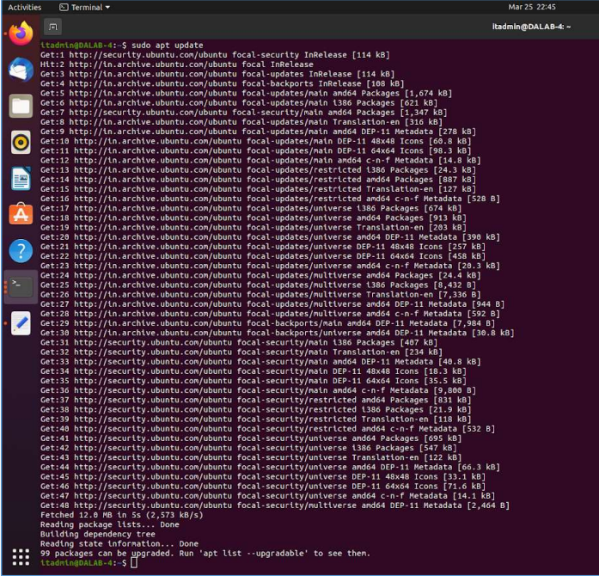

4. Upgrade everything in the system, all the packages, and the kernel to the latest versions as

supported by the repositories:

5. Upgrade existing packages, installs new dependencies that are not in the system, and deletes

those that are not needed:

sudo apt –y upgrade

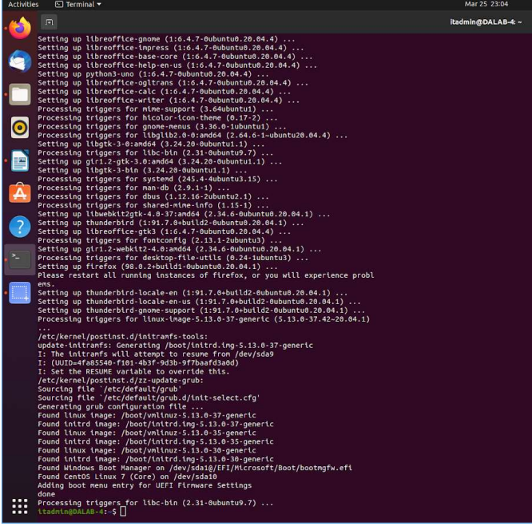

5. Upgrade existing packages, installs new dependencies that are not in the system, and deletes

Those that are not needed:

sudo apt –y dist-upgrad

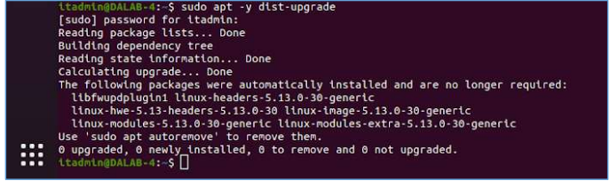

6. Add user called stack to run DevStack. It should be run as non-root user with sudo enabled:

sudo useradd -s /bin/bash -d /opt/stack -m stack

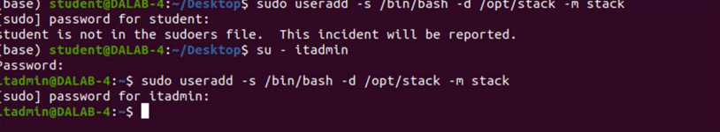

7. User should have sudo privileges to make changes to the system:

echo "stack ALL=(ALL) NOPASSWD: ALL" | sudo tee /etc/sudoers.d/stack



8. Log in to the stack once user is created:

sudo su – stac

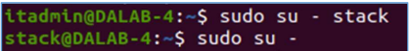

1. Install git:

sudo apt -y install git

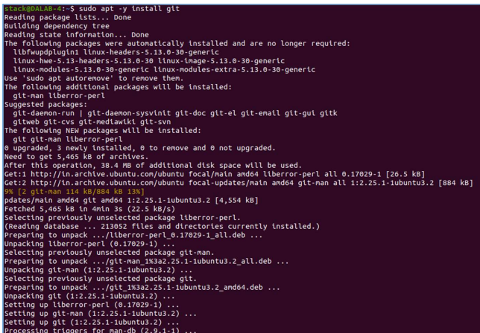

1. Download devstack from its repository into system:

cd devstack

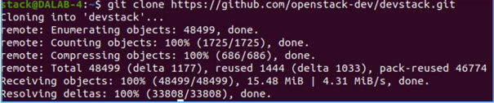

1. Download devstack setup configurations files for it. Need to navigate devstack folder by

running:

nano local.conf

vi local.conf

git clone https://git.openstack.org/openstack-dev/devstack

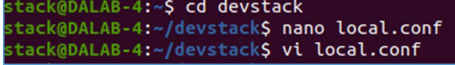

1. Add following inside local.conf:

[local|localrc]] # Password for KeyStone, Database, RabbitMQ and Service ADMIN_PASSWORD=StrongAdminSecret

DATABASE_PASSWORD=$ADMIN_PASSWORD

RABBIT_PASSWORD=$ADMIN_PASSWORD

SERVICE_PASSWORD=$ADMIN_PASSWORD

After setting above, in local.conf, press Esc key and type :wq to write/save and quit

13. Run following to setup Openstack on system:

./stack.sh

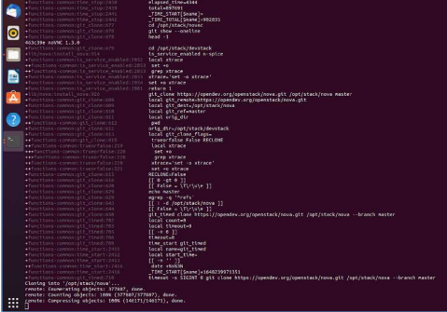

After installation, terminal:

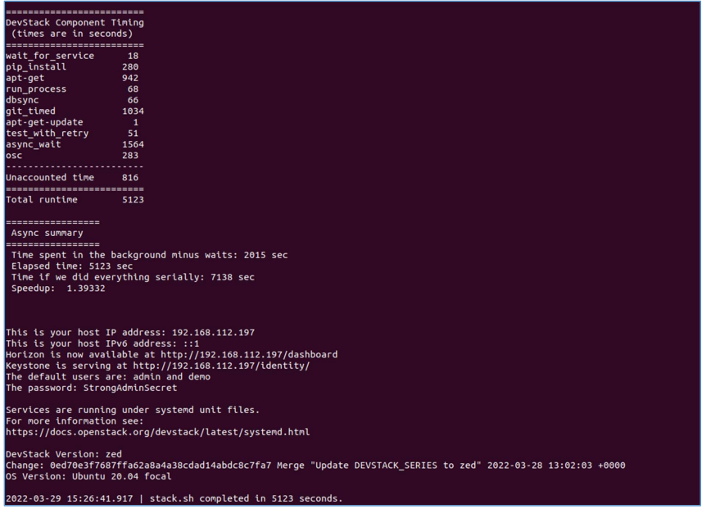

14. Browse URL on browser:

<http://localhost/dashboard>

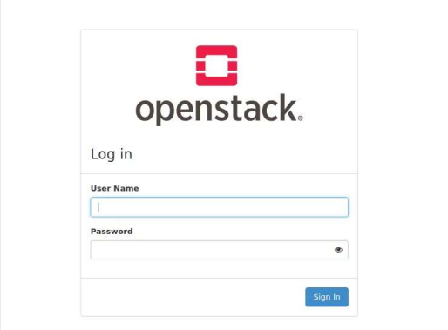

15. Enter credentials. Log in as admin using username ‘admin’ and password as given in

local.conf file:

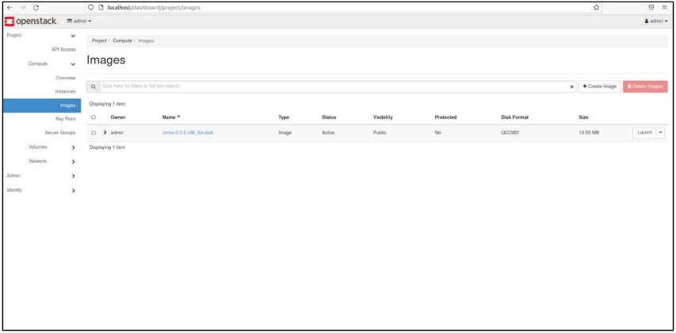



**Result:**

Thus, OpenStack has been successfully installed.

**Creation of VMs in OpenStack**

**Exp no :5 c**

**Aim**:

To deploy a VM in OpenStack and execute a simple application on it.

**Procedure:**

Deploying VM in OpenStack

1. Login to OpenStack using credential

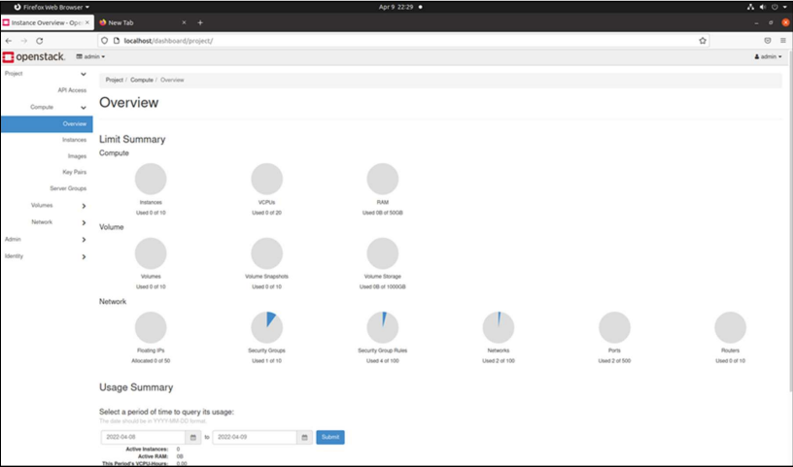

1. Launch an Existing Image Instance in OpenStack

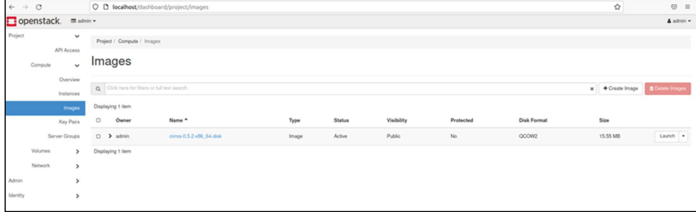

Once launch option is selected, pop-up window is displayed.

1. Give instance name of your choice. Leave the other fields as default values and click next

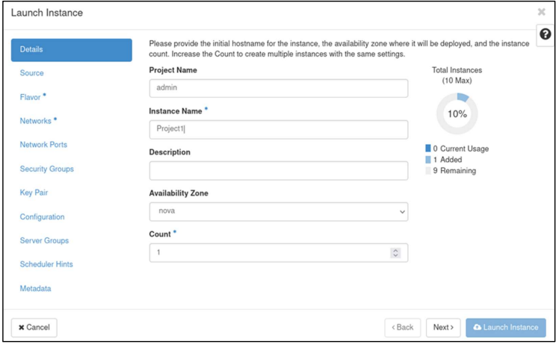

1. Source tab will be next screen in the launch instance window where storage is created and click next

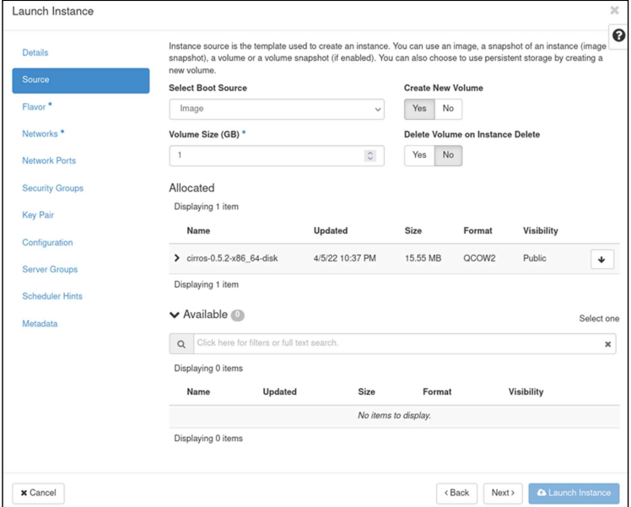

1. Allocate VM resources by adding a flavour best suitable for your needs and click on Next

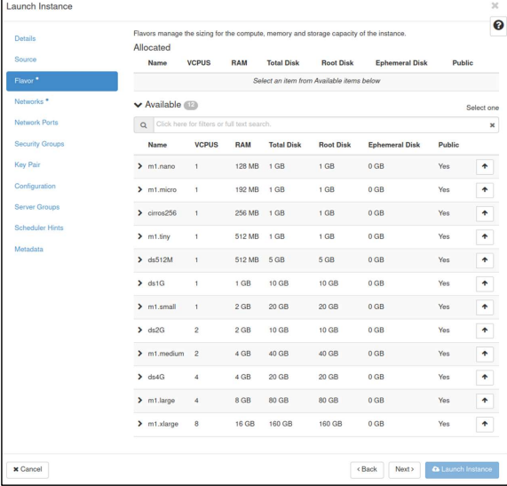

1. From available instance, add instance which already launched so that the instance moves under allocated

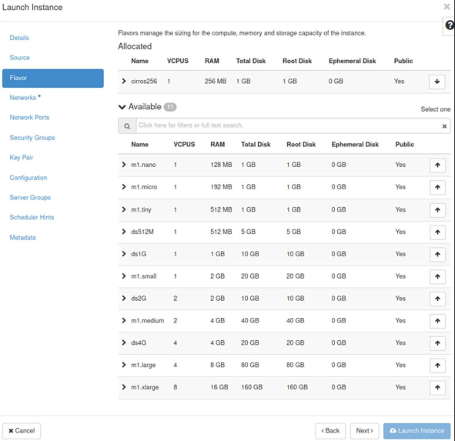

1. Finally, add shared network from available networks in OpenStack to your instance using upward arrow-mark button and hit on ‘Launch Instance’ to start the virtual machine

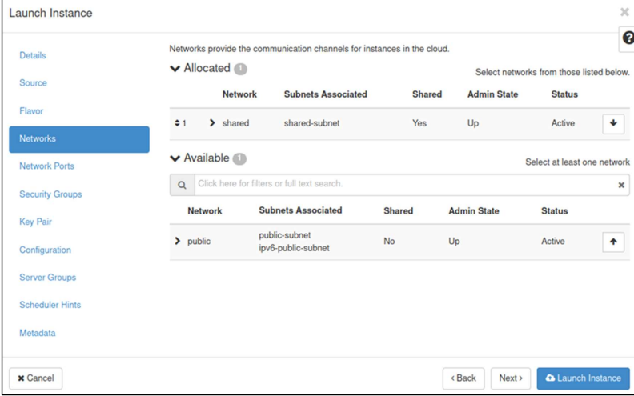

1. Once launch is clicked, select instance in right tab. The added instance is seen under it

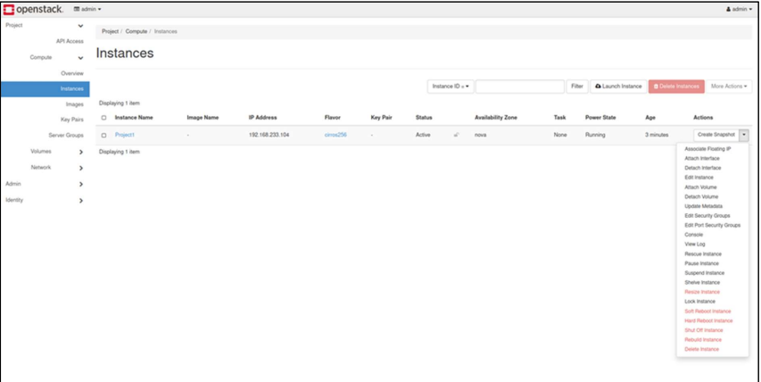

1. Click ‘console’

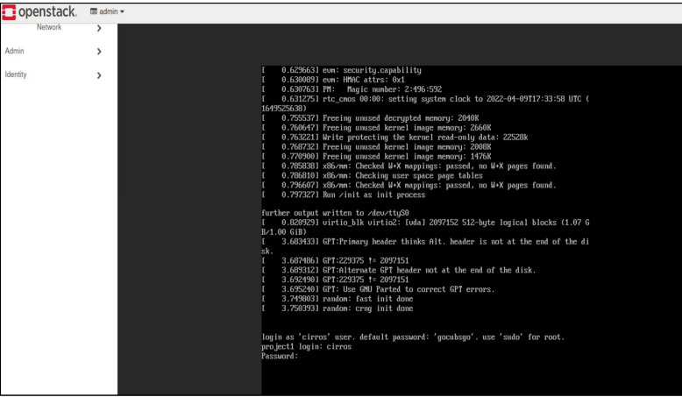

1. Create a text file:

vi test.txt

1. In console type:

ls

1. Display text content using:

Cat test.txt



Result:

Thus, VM has been deployed in OpenStack and a simple application has been executed.

**Exp no :6 a**

**Hadoop Installation**

**Aim:**

To study about the architecture of Hadoop and its components.

**Procedure:**

1. Update system before installation:

sudo apt – update

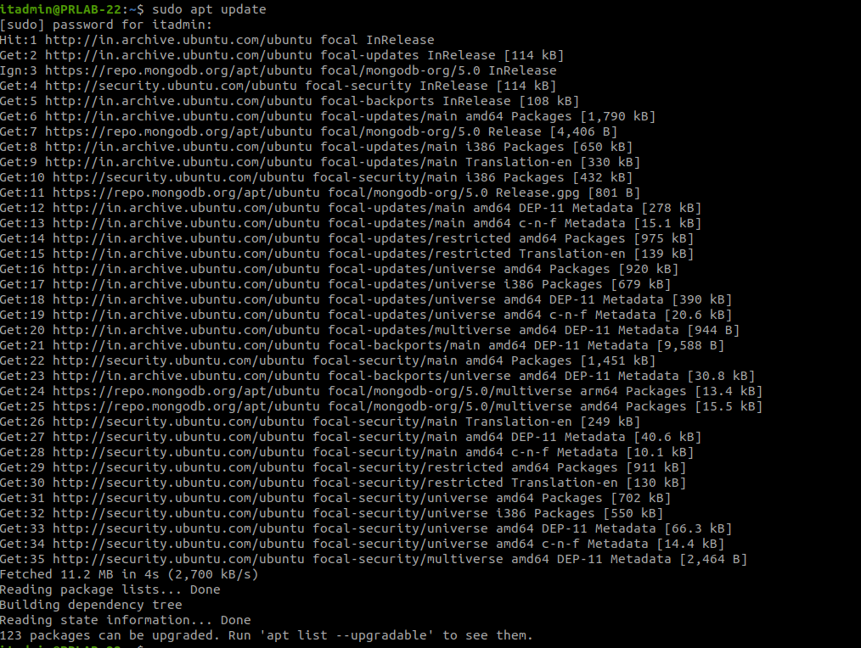

1. Install OpenJDK

sudo apt install openjdk-11-jdk

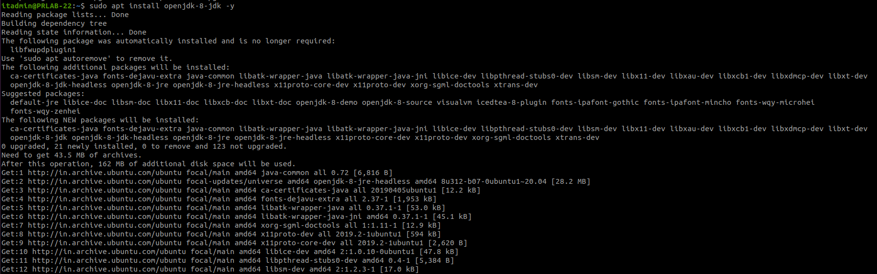

1. Verify intalled Java version

java -version; javac -version

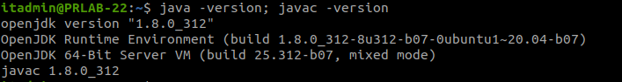

1. Install OpenSSH Server

sudo apt install openssh-server openssh-client -y

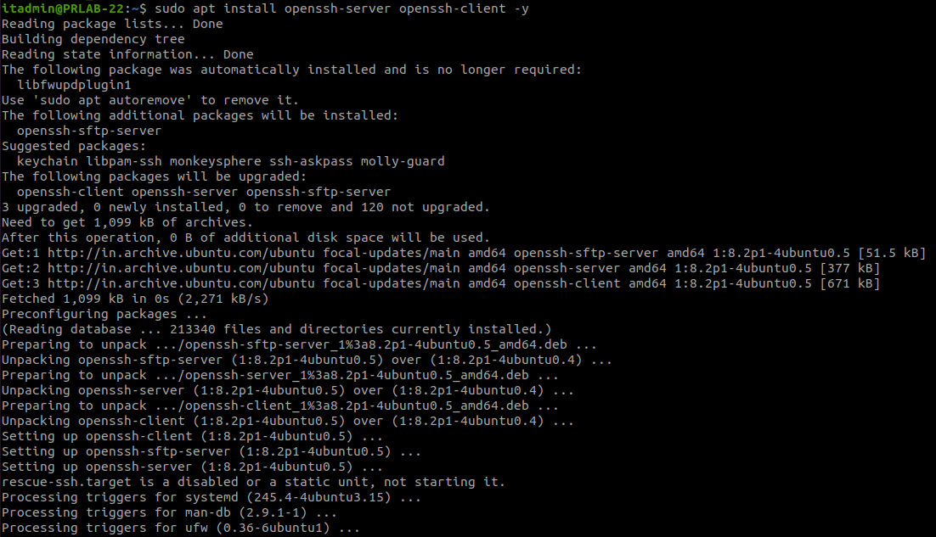

1. Create a Hadoop user

sudo adduser hdoop

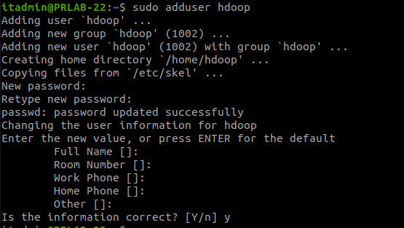

1. Switch to Hadoop user

su - hdoop

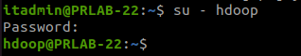

1. Generate an SSH key pair and define the location is is to be stored in

ssh-keygen -t rsa -P '' -f ~/.ssh/id_rsa

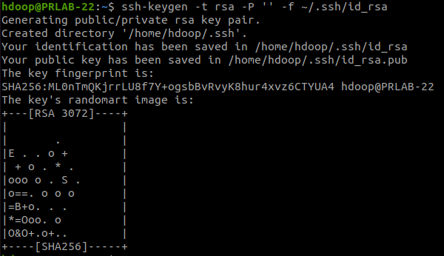

1. Use the cat command to store the public key as authorized_keys in the ssh directory

cat ~/.ssh/id_rsa.pub >> ~/.ssh/authorized_keys

1. Set the permissions for your user with the chmod command

chmod 0600 ~/.ssh/authorized_keys



1. Verify everything is set up correctly by using the hdoop user to SSH to localhost

ssh localhost

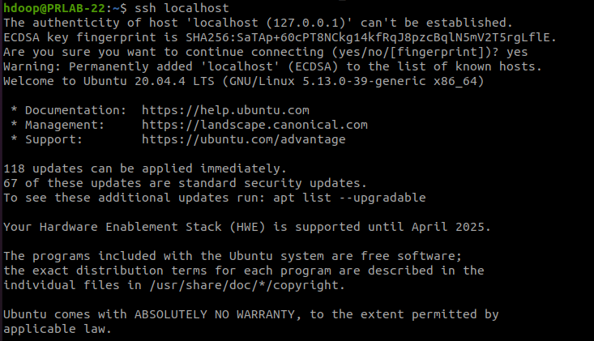

1. Visit the [official Apache Hadoop project page](https://hadoop.apache.org/releases.html), and select the version of Hadoop you want to implement. Click the link to download locally in a machine or install the Hadoop framework in the system using wget command

wget https://dlcdn.apache.org/hadoop/common/hadoop-3.2.3/hadoop-3.2.3.tar.gz





Extract the files to initiate the Hadoop installation.

tar xvzf hadoop-3.2.3.tar.gz

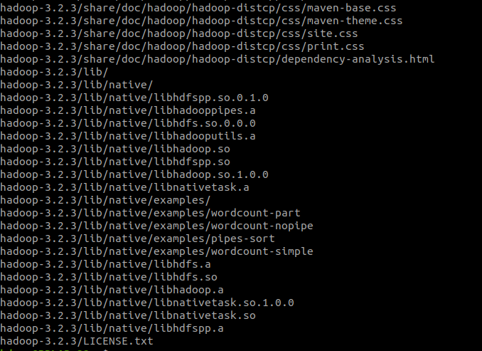

1. Rename the extracted directory by executing the command

mv hadoop-3.2.3 hadoop



1. Configure Java environment variables for setting up Hadoop

dirname $(dirname $(readlink -f $(which java)))



1. Open the “~/.bashrc” file in “vi” text editor. Define the Hadoop environment variables.

vi ~/.bashrc

#Hadoop Related Options

export JAVA_HOME=/usr/lib/jvm/java-8-openjdk-amd64

export HADOOP_HOME=/home/hdoop/hadoop

export HADOOP_INSTALL=$HADOOP_HOME

export HADOOP_MAPRED_HOME=$HADOOP_HOME

export HADOOP_COMMON_HOME=$HADOOP_HOME

export HADOOP_HDFS_HOME=$HADOOP_HOME

export YARN_HOME=$HADOOP_HOME

export HADOOP_COMMON_LIB_NATIVE_DIR=$HADOOP_HOME/lib/native

export PATH=$PATH:$HADOOP_HOME/sbin:$HADOOP_HOME/bin

export HADOOP_OPTS="-Djava.library.path=$HADOOP_HOME/lib/native"

1. Apply the changes to the current running environment

source ~/.bashrc

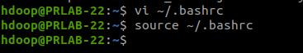

1. Add the full path to the OpenJDK installation on your system

export JAVA_HOME=/usr/lib/jvm/java-8-openjdk-amd64

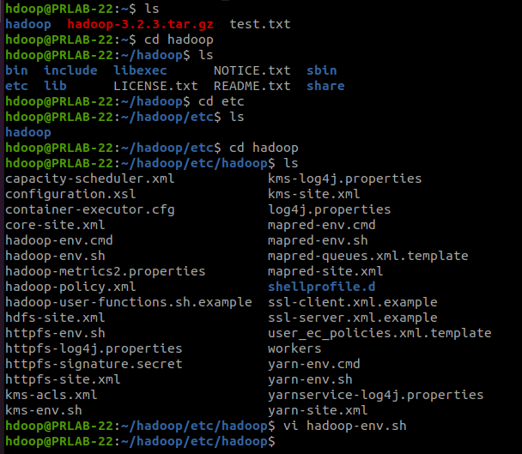

1. Configure Apache Hadoop on the Ubuntu system. For this, the step is to create two directories: datanode and namenode, inside the home directory of Hadoop.

mkdir -p ~/dfsdata/namenode

mkdir -p ~/dfsdata/datanode

1. Specify the URL for your NameNode, and the temporary directory Hadoop uses for the map and reduce process. Go to specific directory and open core-site.xml



Add the following configuration to override the default values for the temporary directory and add your HDFS URL to replace the default local file system setting

<property>

<name>hadoop.tmp.dir</name>

<value>/home/hdoop/tmpdata</value>

</property>

<property>

<name>fs.default.name</name>

<value>hdfs://127.0.0.1:9000</value>

</property>

1. Configure the file by defining the NameNode and DataNode storage directories in hdfs-site.xml



Add the following configuration to the file and, if needed, adjust the NameNode and DataNode directories to your custom locations.

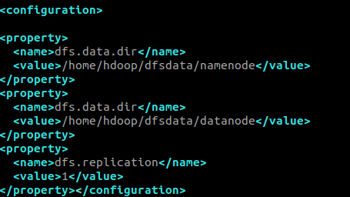

1. Use the following command to access the mapred-site.xml file and define MapReduce values:



Add the following configuration to change the default MapReduce framework name value to yarn

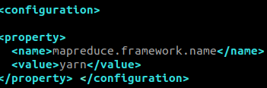

1. Edit yarn-site.xml File

Open the yarn-site.xml file in a text editor:

nano $HADOOP_HOME/etc/hadoop/yarn-site.xml

Append the following configuration to the file



1. Format HDFS NameNode

hdfs namenode -format

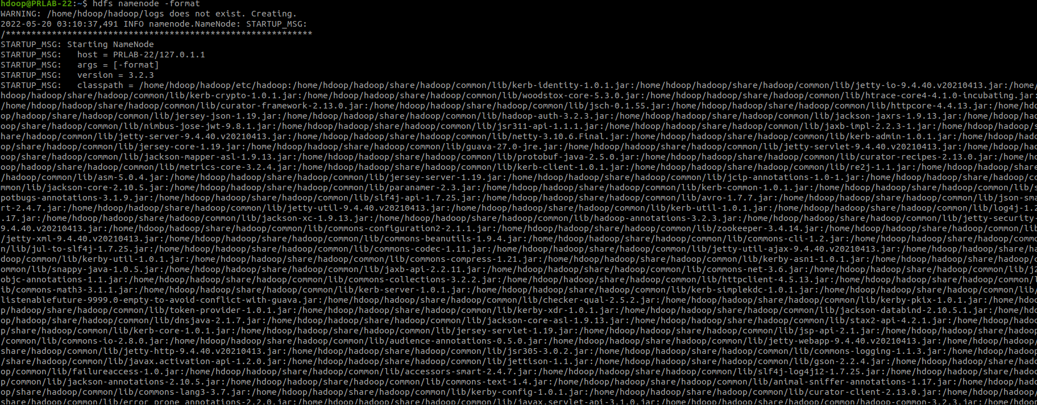

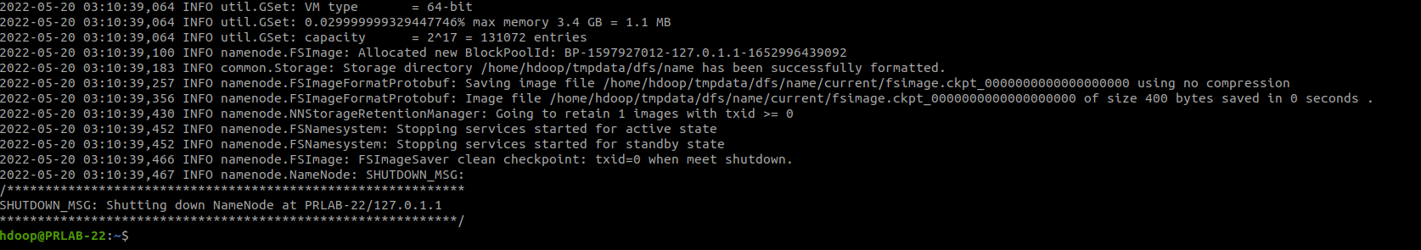

1. Start Hadoop Cluster

./start-dfs.sh

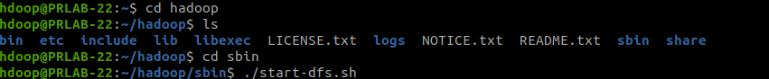



1. Once the namenode, datanodes, and secondary namenode are up and running, start the YARN resource

./start-yarn.sh

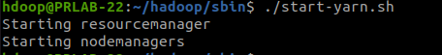

1. Check if all the daemons are active and running as Java processes

jps

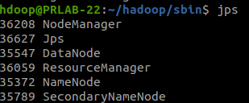

1. Access Hadoop UI from Browser

http://localhost:9870

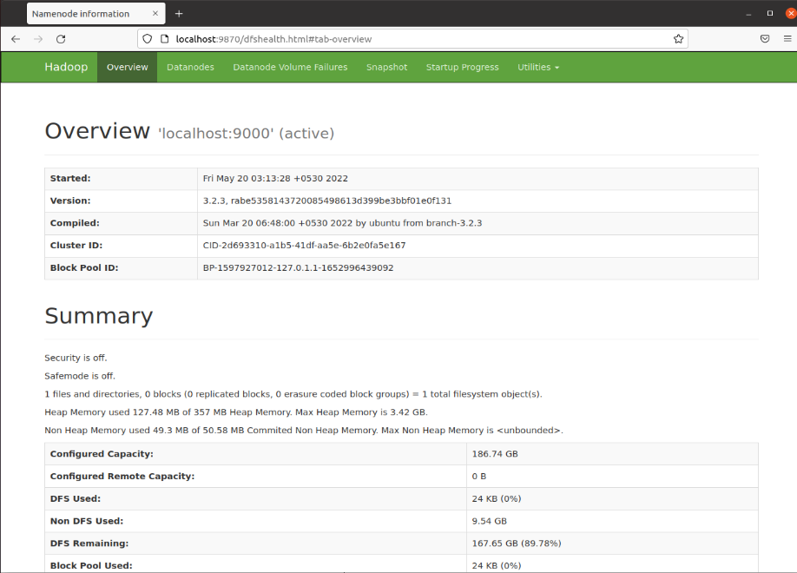

1. The default port 9864 is used to access individual DataNodes directly from browser

http://localhost:9864

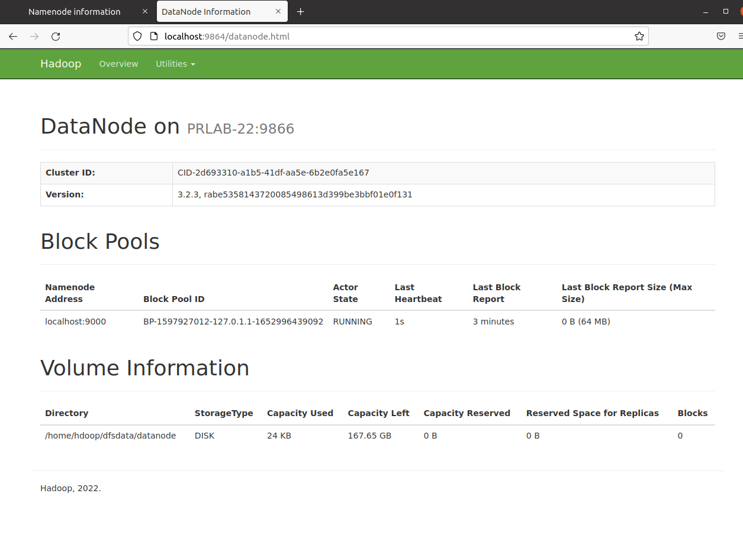

1. The YARN Resource Manager is accessible on port 8088. The Resource Manager is an invaluable tool that allows to monitor all running processes in Hadoop cluster

http://localhost:8088

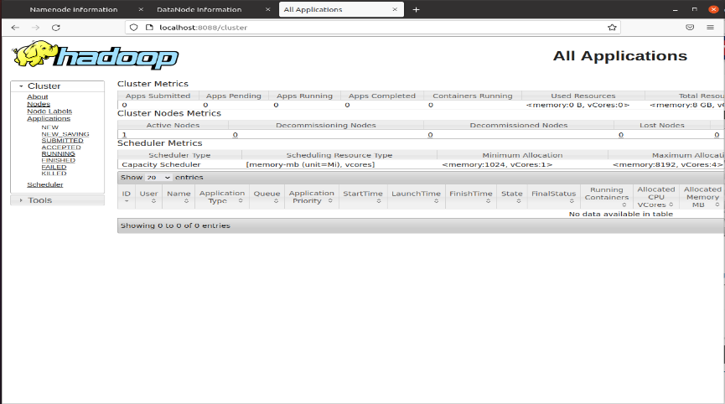

1. Stop the NameNode, DataNode and YARN

./~stop-yarn.sh

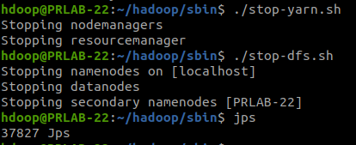



**Result:** Thus, Hadoop has been successfully installed.



**Exp no : 6 b**

**File Management in Hadoop**

**Aim:** To implement file management in the Hadoop File System of Hadoop.

**Codes and Output:**

1. Adding Directories

hadoop fs -mkdir /sample



Login to the web browser

http://localhost:9870

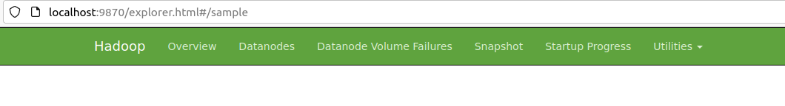

Under Utilities → click (Browse the file system option)

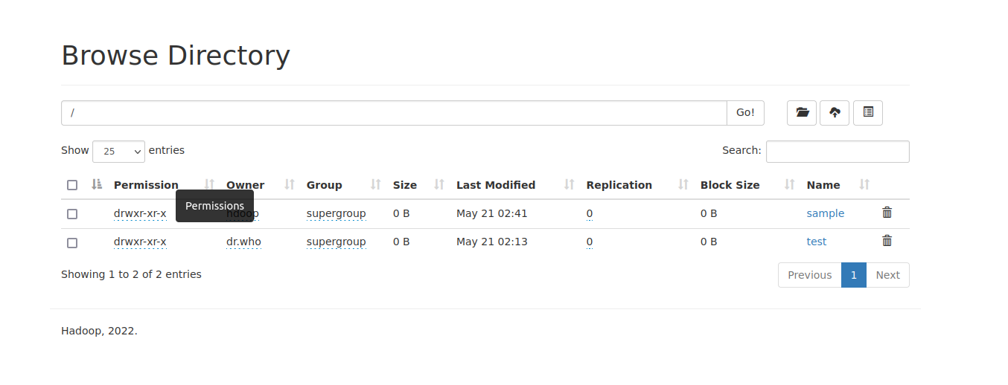 

1. Adding Files

Create a new file in the terminal

vi eg.txt



Type contents and save it and exit out of the file. Move the file to the newly created directory.

hadoop fs -put eg.txt /sample

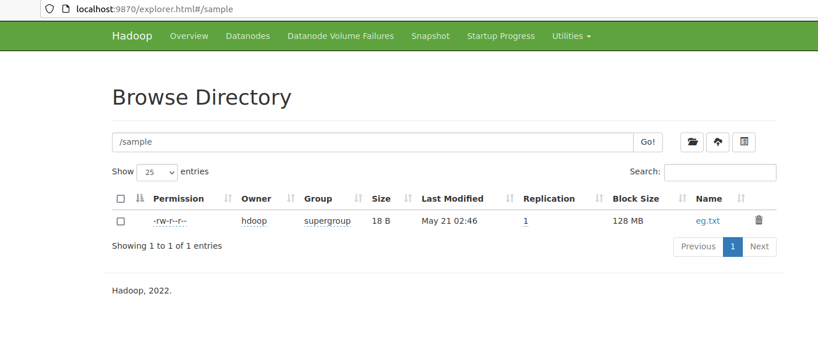 

1. Retrieve File Contents

hadoop fs -cat /sample/eg.txt



1. Delete File

Create a new file and move to the directory ‘sample’

vi hsample.txt

hadoop fs -put hsample.txt /sample

hadoop fs -cat /sample/hsample.txt

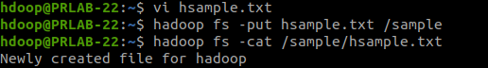

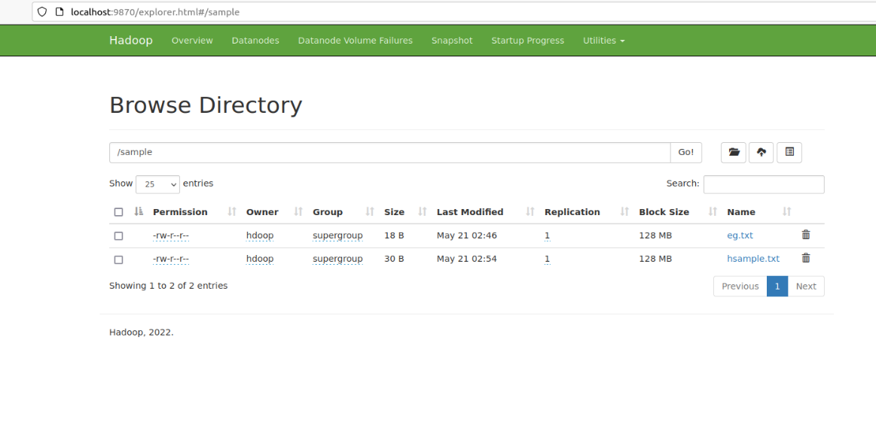

hadoop fs -rm /sample/hsample.txt



After deletion

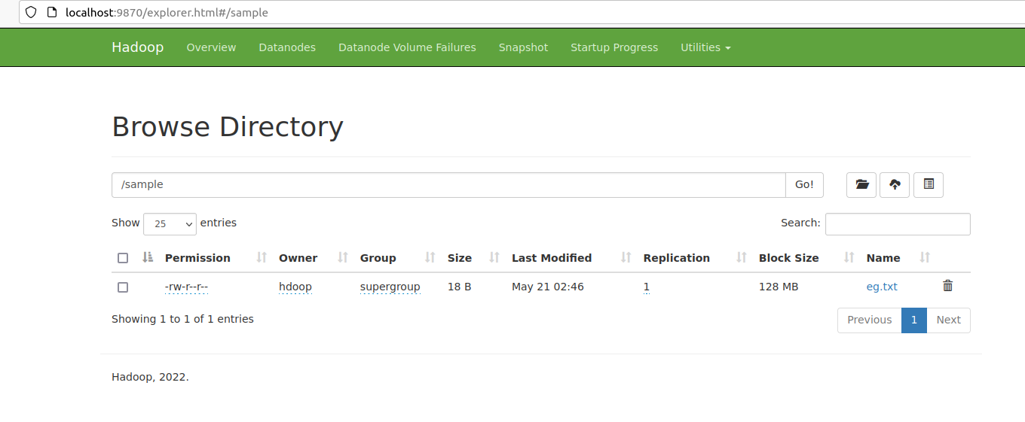



**Result:** Thus, file management in HDFS of Hadoop has been successfully carried out.

**Exp. No.: 7 a**

**Hive Installation**

**Aim:**

To install Hive.

**Procedure:**

1. Download Apache HIVE latest release

Visit https://hive.apache.org/downloads.html

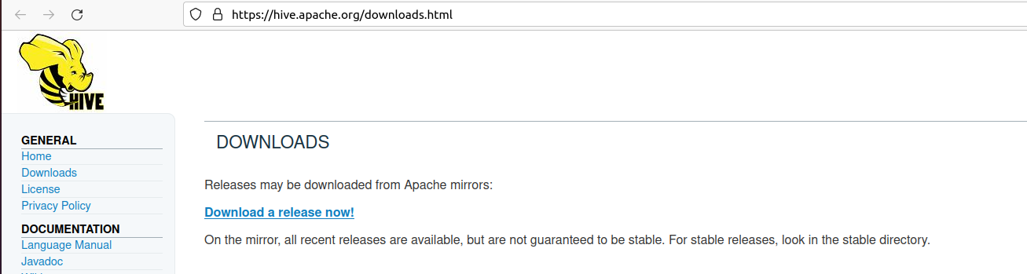

1. In terminal, switch to the user where Hadoop is installed

su – hdoop

wget https://dlcdn.apache.org/hive/hive-3.1.2/apache-hive-3.1.2-bin.tar.gz

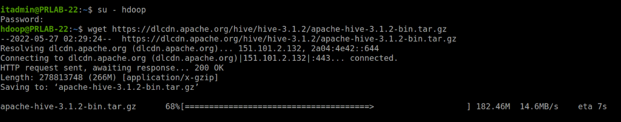

1. Extract the files to initiate the Hive installation

tar xvzf apache-hive-3.1.2-bin.tar.gz

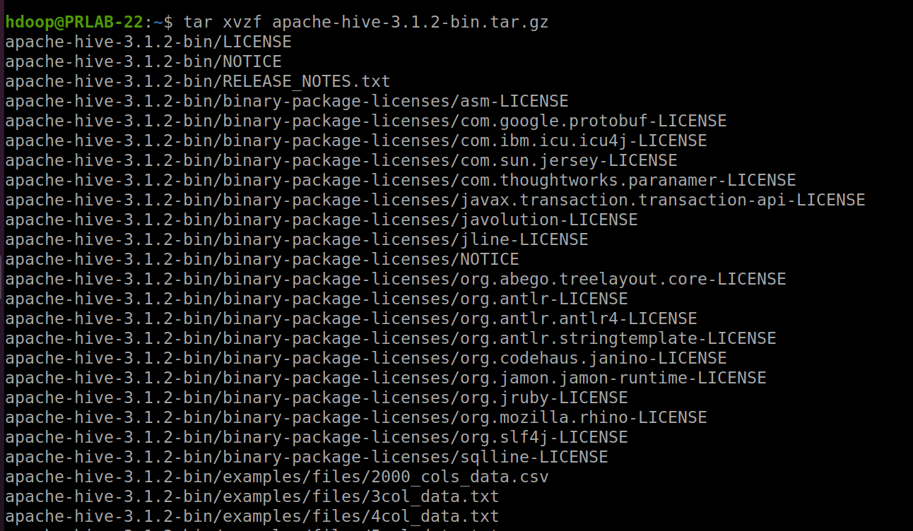

1. Configure Hive Environment Variables (bashrc)

vi .bashrc

Append the following Hive environment variables to the .bashrc file:

export HIVE_HOME= "/home/hdoop/apache-hive-3.1.2-bin"

export PATH=$PATH:$HIVE_HOME/bin

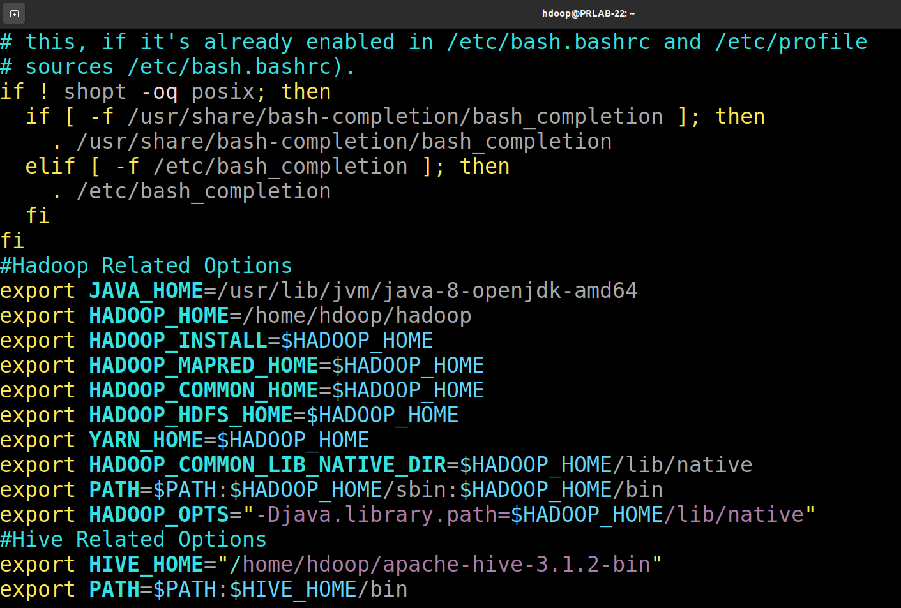

1. Apply the changes to the current environment

source ~/.bashrc



1. Edit hive-config.sh file

vi $HIVE_HOME/bin/hive-config.sh

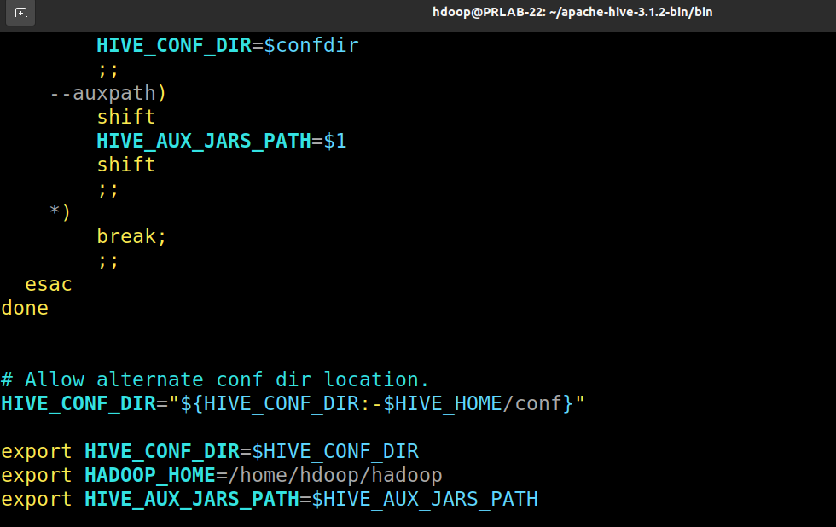

Start hadoop file system and yarn using the commands which were given during hadoop installation procedure.

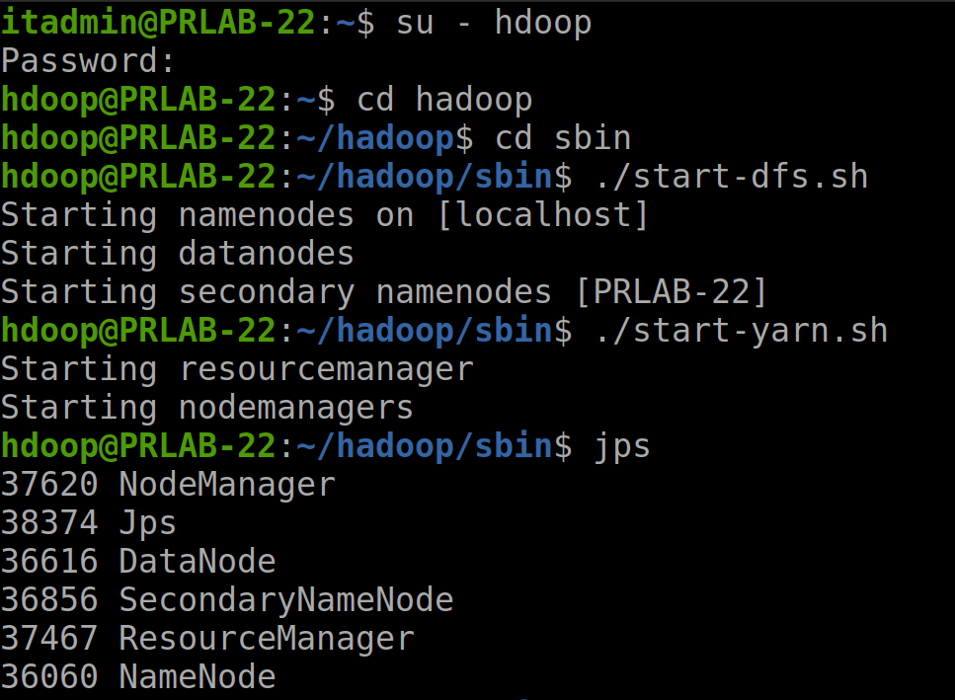

1. Create two separate directories to store data in the HDFS layer

hadoop fs -mkdir /tmp

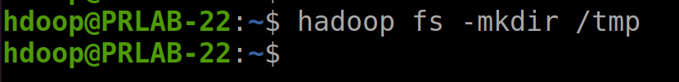

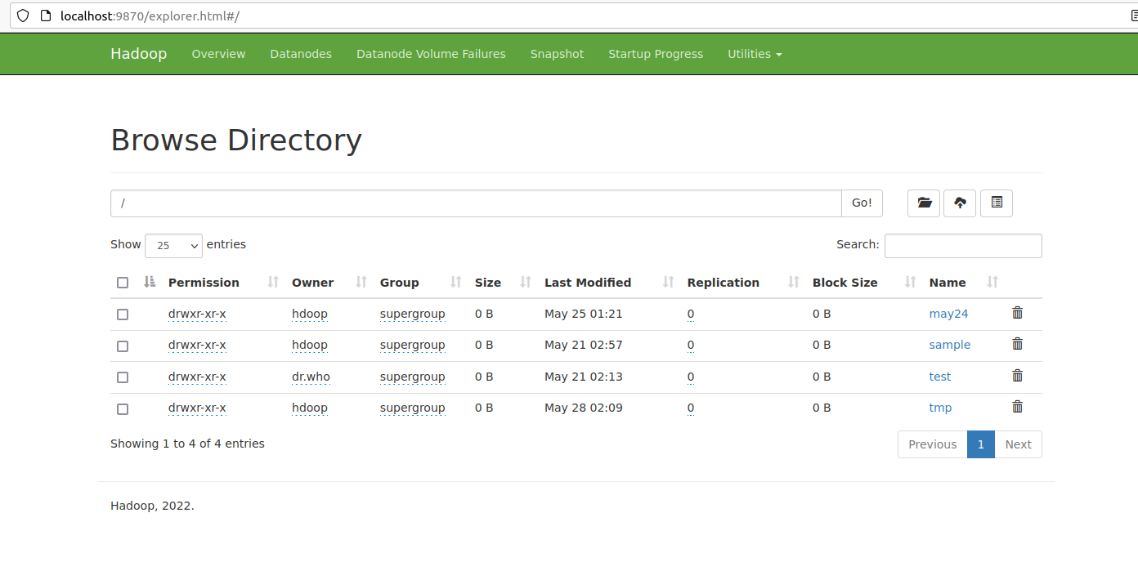

hadoop fs -chmod g+w /tmp

Add write and execute permissions to tmp group members

Check if the permissions were added correctly

hadoop fs -ls /

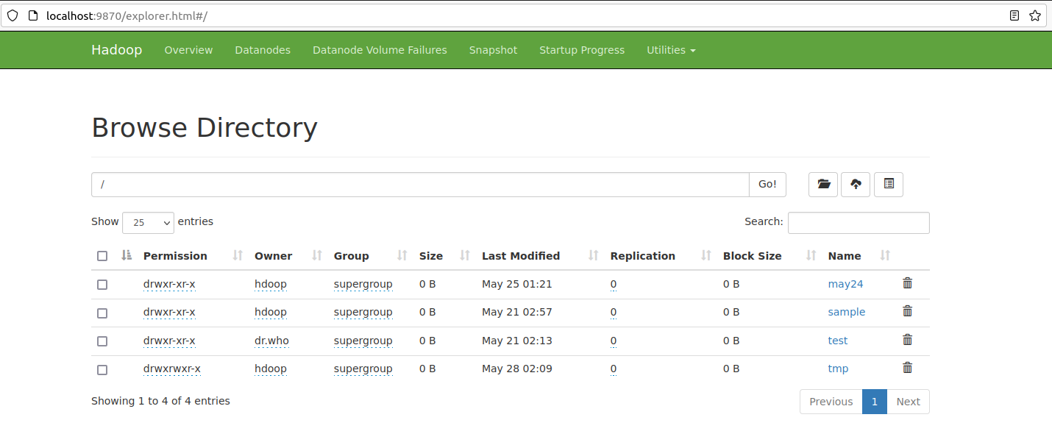

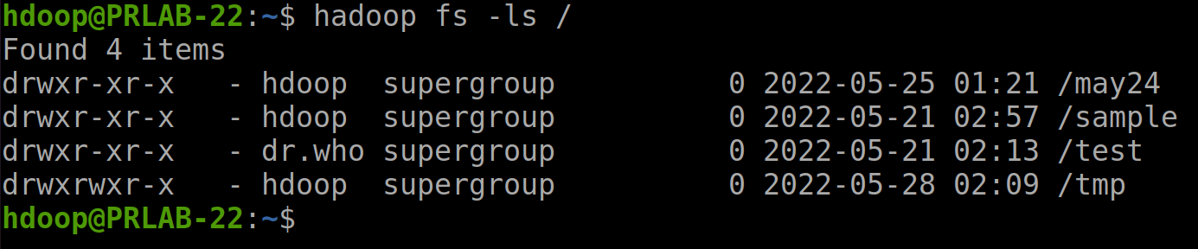

Create warehouse Directory. Create the warehouse directory within the /user/hive/ parent directory

hadoop fs -mkdir -p /user/hive/warehouse

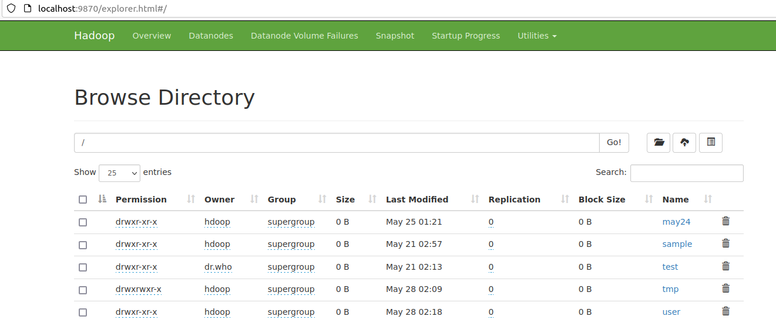

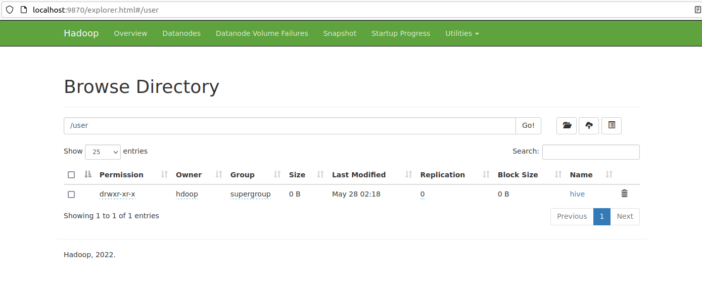

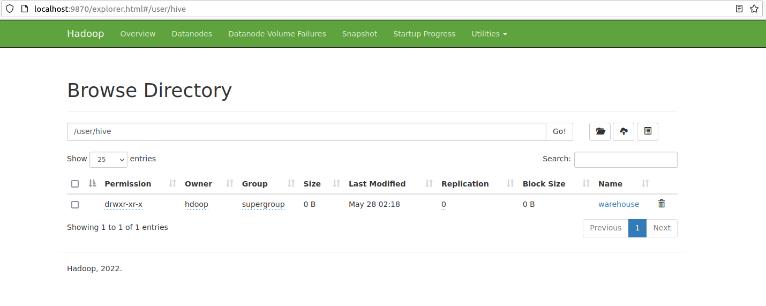

Add write and execute permissions to warehouse group members

hadoop fs -chmod g+w /user/hive/warehouse



Check if the permissions were added correctly

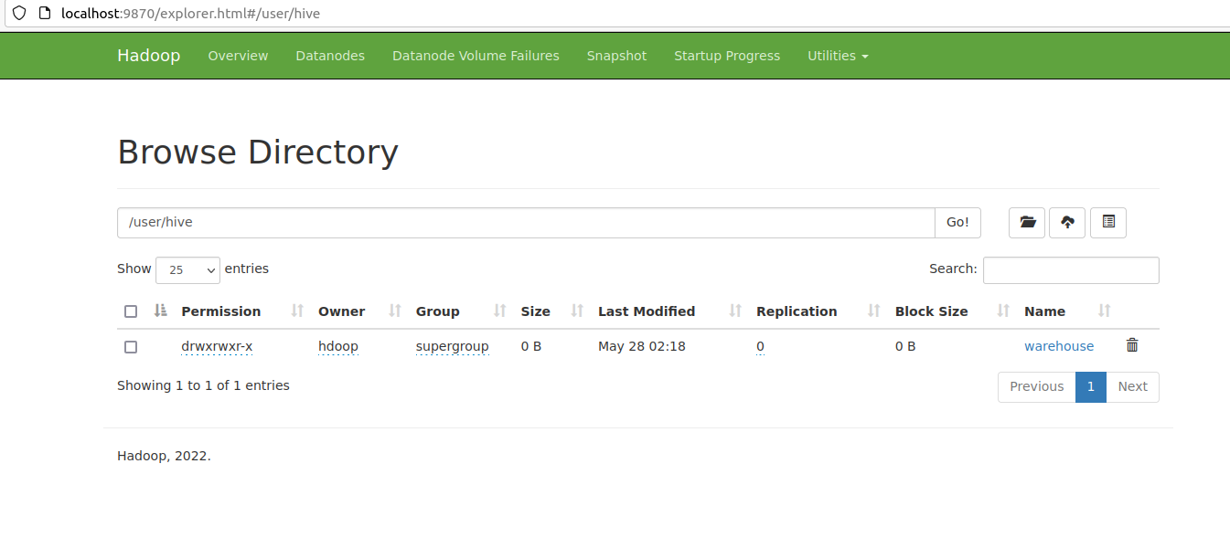

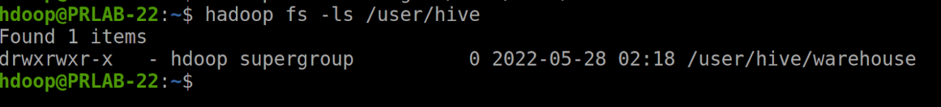

1. Configure hive-site.xml File

cd $HIVE_HOME/conf

List the files contained in the folder using the ls command

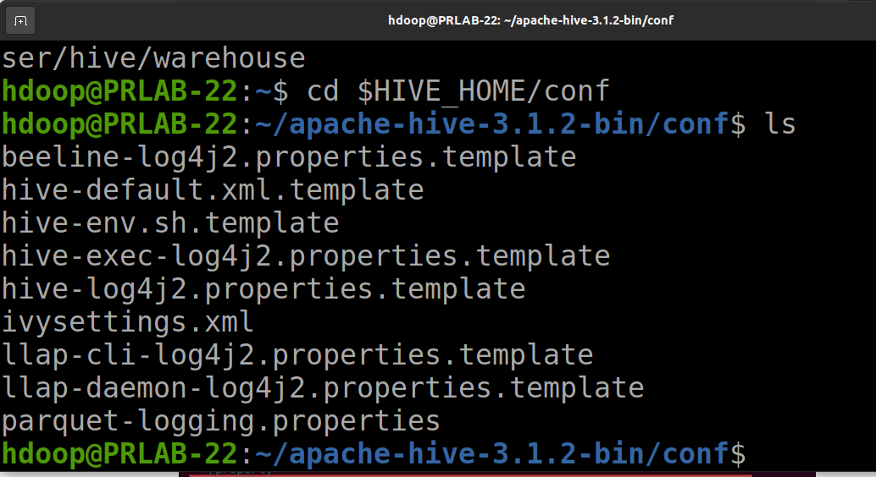

Use the hive-default.xml.template to create the hive-site.xml file:



Access the hive-site.xml file using the text editor of your choice



Using Hive in a stand-alone mode rather than in a real-life Apache Hadoop cluster is a safe option

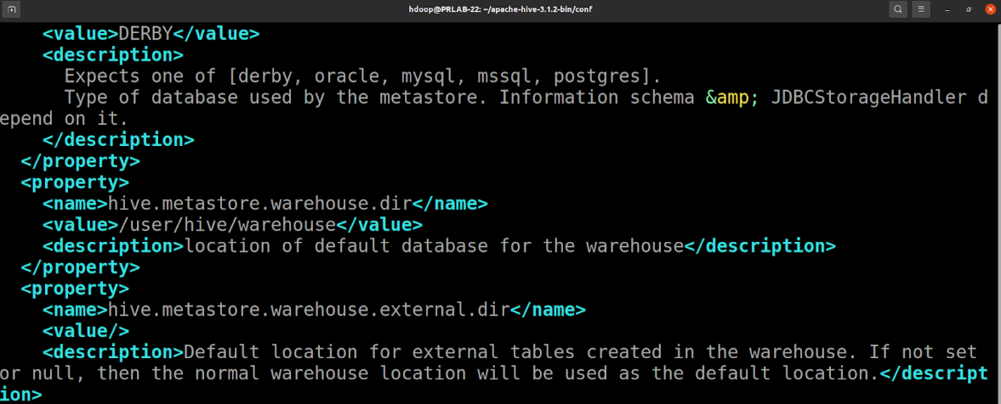

1. Initiate Database

$HIVE_HOME/bin/schematool -dbType derby -initSchema

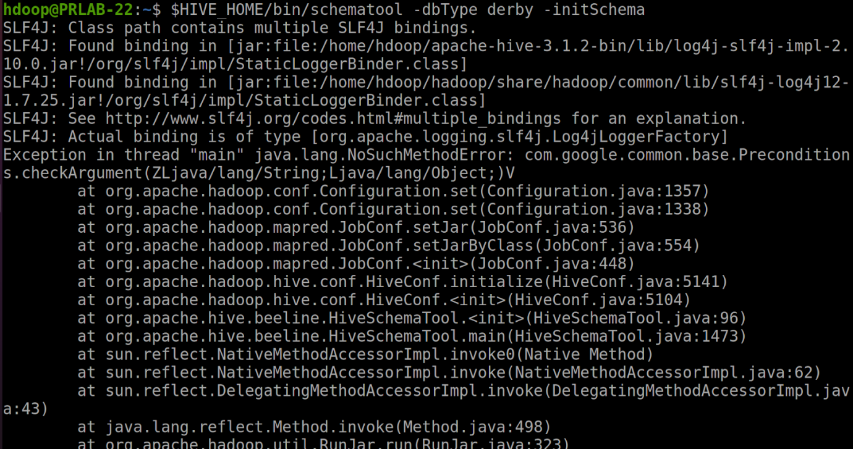

1. Remove the existing guava file from the Hive lib directory

rm $HIVE_HOME/lib/guava-19.0.jar



1. Use the schematool command once again to initiate the Derby database

$HIVE_HOME/bin/schematool -dbType derby -initSchema

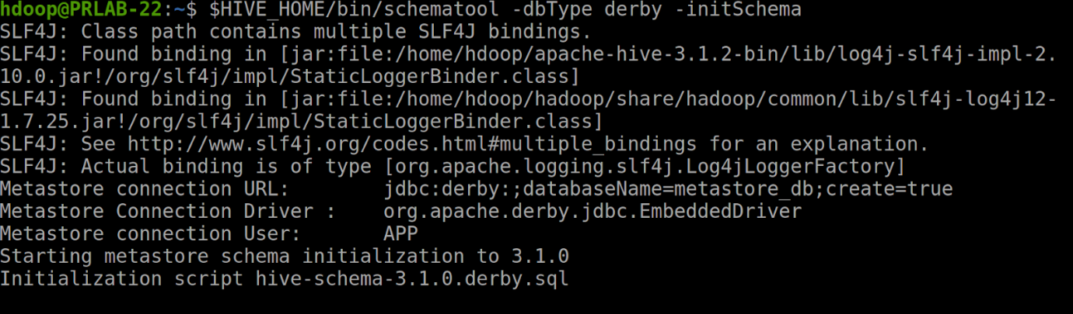

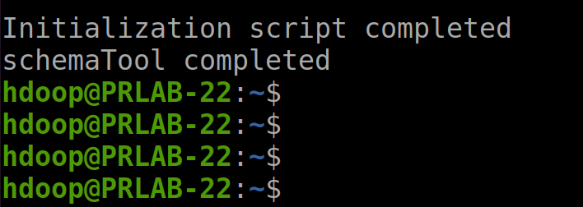

1. Launch Hive Client Shell on Ubuntu

cd $HIVE_HOME/bin/hive

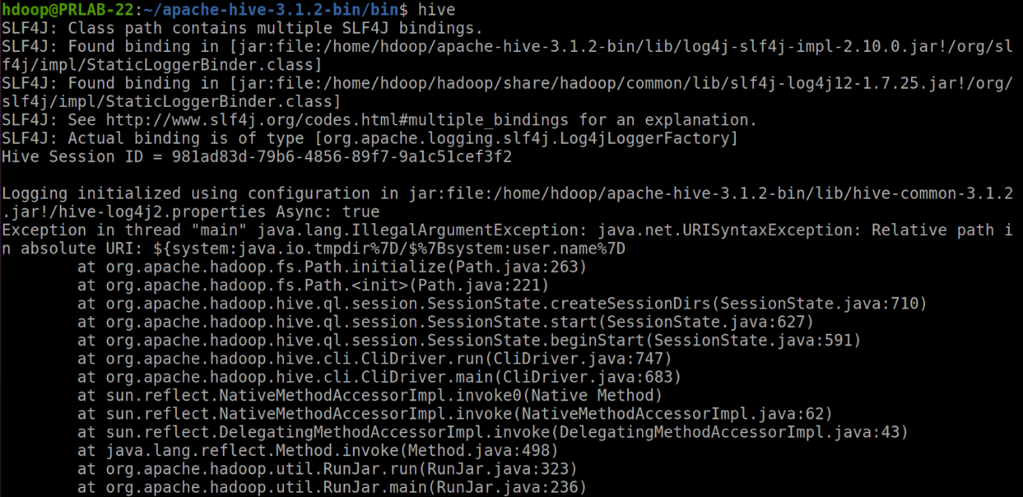

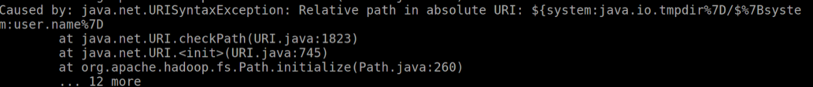

1. Error may occur when hive-shell started before metastore_db service. To avoid this just delete or move your metastore_db and try the below command

$ mv metastore_db metastore_db.tmp

1. Once again to initiate the Derby database

$ schematool -dbType derby -initSchema



tar xvzf apache-hive-3.1.2-bin.tar.gz

**Result:**

Thus, Hive has been successfully installed.

**Exp. No:7 b**

**Hive CRUD Operations**

**Aim:**

To implement a schema definition in Hive and perform CRUD operations.

**Procedure:**

Codes and Output:

1. Table Creation

Create table studentnew (id int, name string, location string) cluster by (location) into 3 buckets row format delimited fields terminated by ‘,’ lines terminated by ‘\n’ stored as orc TABLEPROPERTIES (‘transactional’ = ‘true’);

Output:

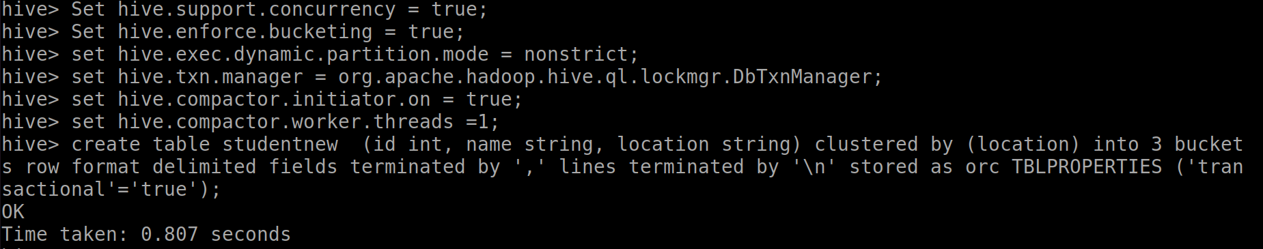



1. Insertion of Records

INSERT INTO TABLE studentnew VALUES (101,’abc’,’GST Road’),

(102,’A’,’Guindy’), (103,’PRABU’,’henry road’), (104,’KUMAR’,’gandhi road’);

Output:

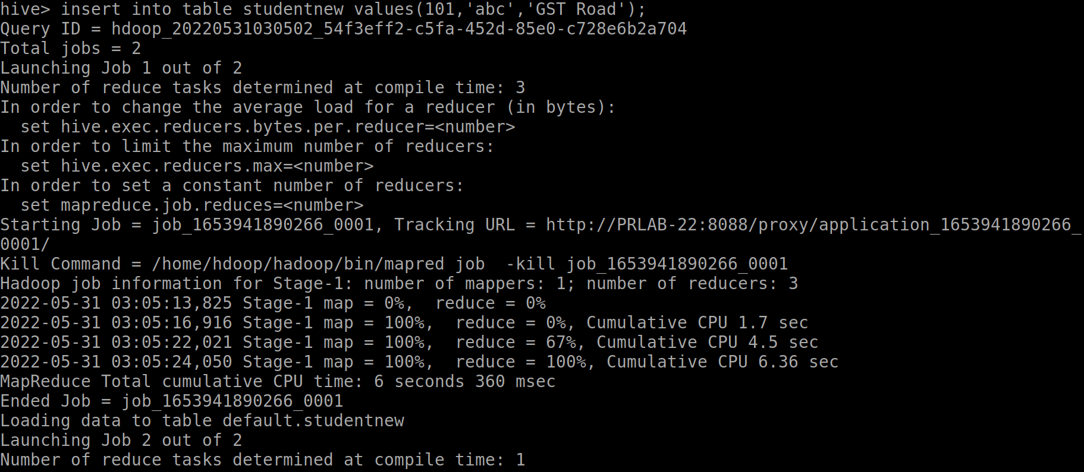

1. Retrieve of Records

select * from studentnew

Output:

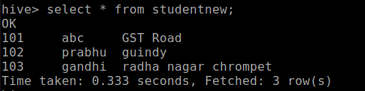

1. Updation of Records

Update studentnew SET id = 113 WHERE id = 103;

Output:

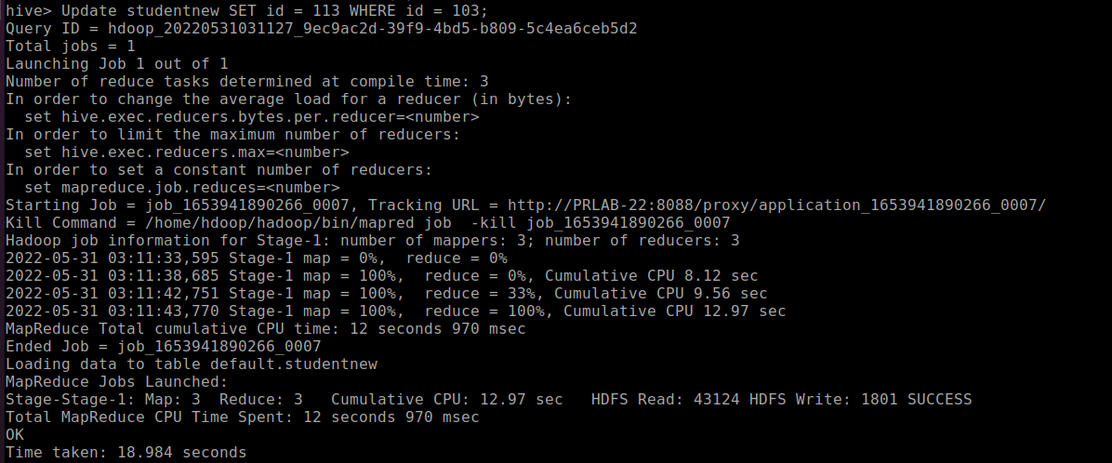

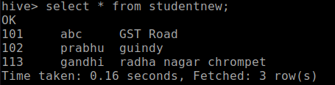



1. Deletion of Records

delete from studentnew where id=102;

Output:

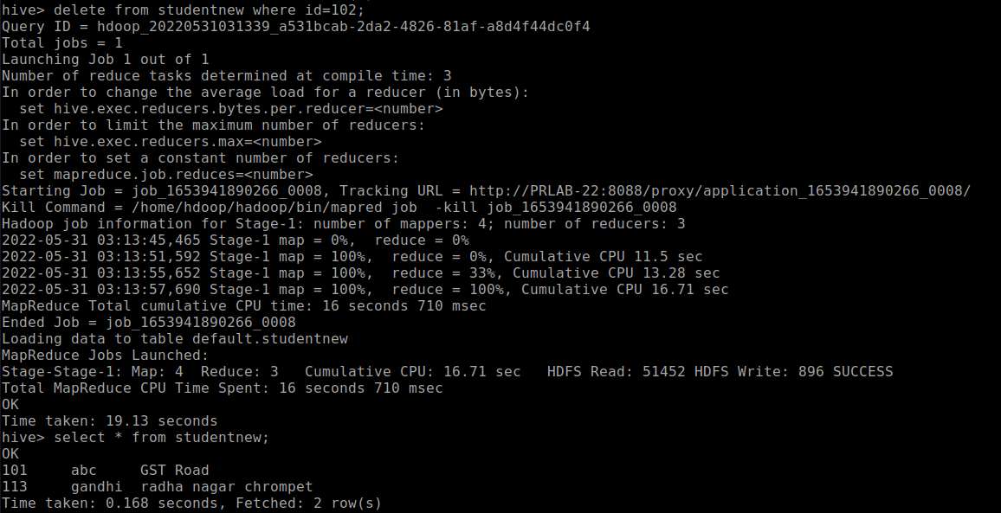



View the table created in Browser-UI

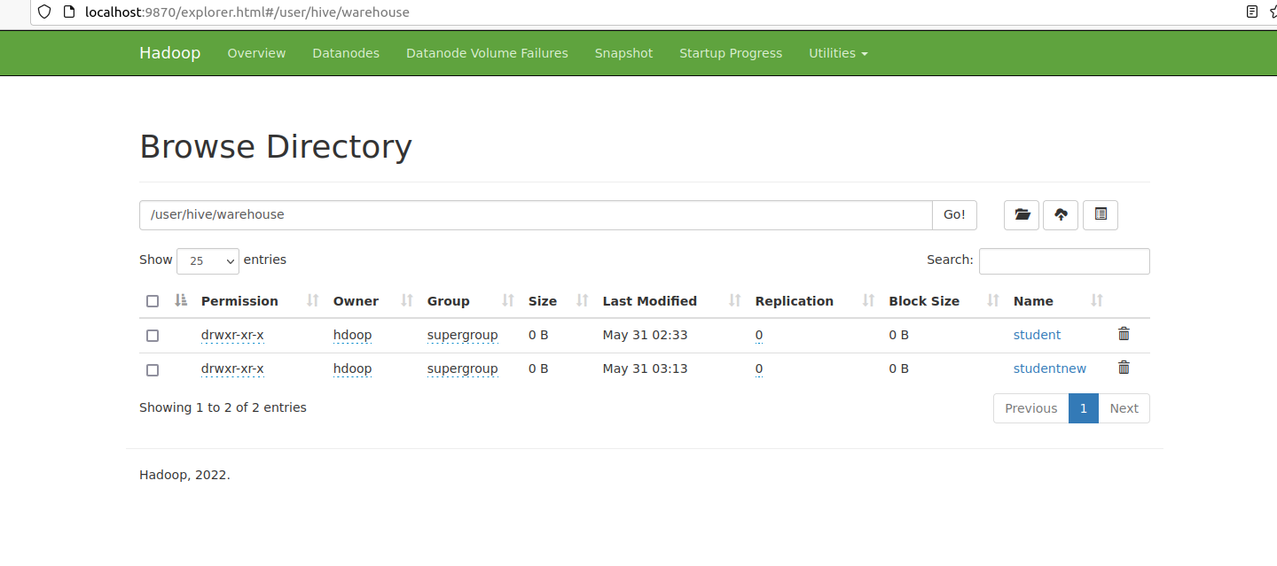



**Result:** Thus, a schema definition has been created in Hive and CRUD operations have been performed.

**MongoDB Basics**

**Exp. No.:** 8 a

**Aim:**

To study about the basics of MongoDB and its operations.



**Theory:**

MongoDB is a general-purpose document database designed for modern application development and for the cloud. Its scale-out architecture allows you to meet the increasing demand for your system by adding more nodes to share the load.

MongoDB is a cross-platform, document oriented database that provides, high performance, high availability, and easy scalability. MongoDB works on concept of collection and document.



Document

MongoDB stores data as JSON documents. The document data model maps naturally to objects in application code, making it simple for developers to learn and use. A document is a set of key-value pairs. Documents have dynamic schema. Dynamic schema means that documents in the same collection do not need to have the same set of fields or structure, and common fields in a collection's documents may hold different types of data. Documents can be nested to express hierarchical relationships and to store structures such as arrays.



Collection

Collection is a group of MongoDB documents. It is the equivalent of an RDBMS table. A collection exists within a single database. Collections do not enforce a schema. Documents within a collection can have different fields. Typically, all documents in a collection are of similar or related purpose.



_id is a 12 bytes hexadecimal number which assures the uniqueness of every document. The first 4 bytes for the current timestamp, next 3 bytes for machine id, next 2 bytes for process id of MongoDB server and remaining 3 bytes are simple incremental VALUE.



Sample Document

{

‘_id’: ObjectId(7df78ad8902c),

‘Name’: ‘ABC’,

‘Age’: 20,

‘Reg_No’: ‘201901a’,

‘Subjects’: [ ‘Math’, ‘English’],

‘Details’: { ‘Father’ : ‘XY’,

‘Mother’ : ‘PQ’

}

}



Operations

1. Use

* To create and use a database. If the database exists, it returns existing database
* Syntax:
* use Database_name

1. Create

* To create/insert a new document to a collection
* Syntax:
* db.collection_name.insertOne( )
* db.collection_name.insertMany( )

1. Read

* To retrieve documents from a collection
* Syntax:
* db.collection_name.find( )

1. Update

* To modify existing documents in a collection
* Syntax:
* db.collection_name.updateOne( )
* db.collection_name.updateMany( )
* db.collection_name.replaceOne( )

1. Delete

* To remove documents from a collection
* Syntax:
* db.collection_name.deleteOne( )
* db.collection_name.deleteMany( )



**Result:**

Thus, a study on the basics of MongoDB and its operations has been made.



**2. Pick any system as an example, create database and its corresponding tables. Also populate the tables with data. Apply insert /search operations**

**Aim:**

To design a student management system using MongoDB and perform CRUD operations on it.



**Code:**

1. Create and Use Database ‘StuDB’

use StuDb

db

Output:

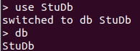



1. Insert

* Insert one document into collection

db.StuDb.insert( { “StuId” : 1, “Name” : “Ashwin”, “Age” : 19, “Marks” : { “Math” : 100, “English” : 99 } } )

Db.StuDB.find( ).pretty( )

Output:

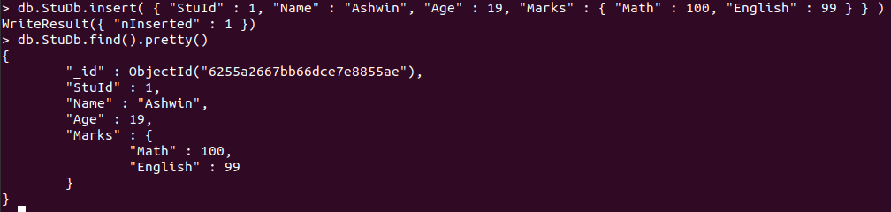

* Insert multiple documents into collection

db.StuDb.insertMany( [ { “StuId” : 2, “Name” : “Charlie”, “Age” : 20, “Marks” : { “Math” : 98, “English” : 100 } } , { “StuId” : 3, “Name” : “David”, “Age” : 20, “Marks” : { “Math” : 89, “English” : 78 } }, { “StuId” : 4, “Name” : “Davis”, “Age” : 20, “Marks” : { “Math” : 96, “English” : 95 } } ] )

Output:

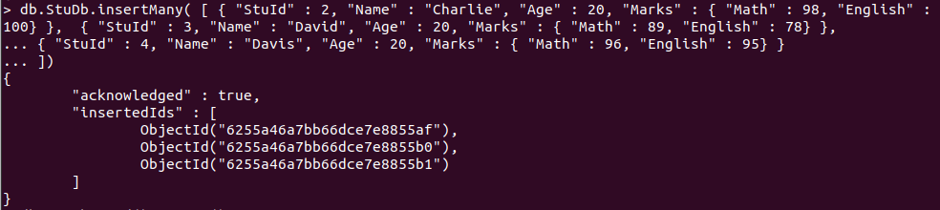

1. Search

* Find document where ‘StuId’ is 3

db.StuDb.find( { ‘StuID’ : 3 } ).pretty( )

Output:

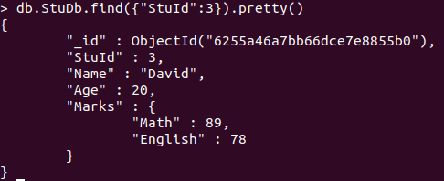

* Find documents where marks in English is less than 80

db.StuDb.find( { ‘Marks.English’ : { $lt : 80 } } )

Output:

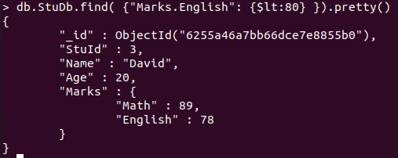



1. View

db.StuDb.find( ).pretty( )

Output:

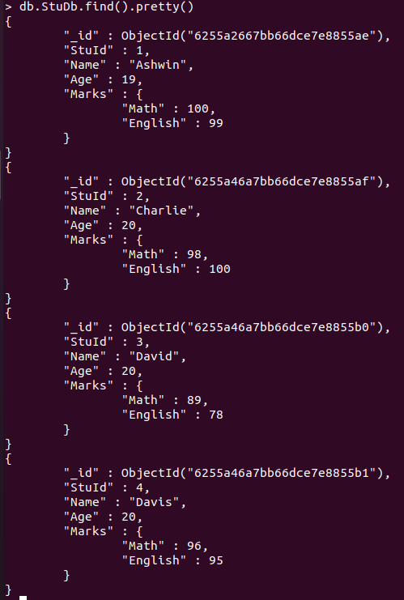

1. Update

Update the marks in English to 80 for all documents in collection where marks in math is less than 95.

db.StuDb.updateMany( { ‘Marks.Math’ : { $lt : 95 }}, { $set : { ‘Marks.English’ : 80 } } )

db.StuDb.find( { ‘Marks.Math’ : { $lt : 95 } } ).pretty( )

Output:

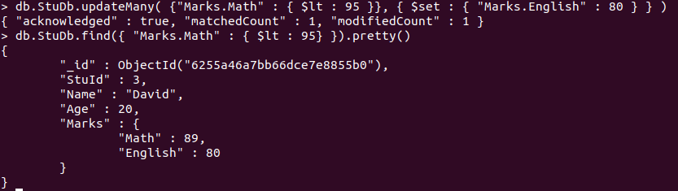



1. Delete

Delete all documents that have marks in math less than 97.

db.StuDb.deleteMany( { ‘Marks.Math’ : { $lt : 97 } } )

db.StuDb.find( ).pretty( )

Output:

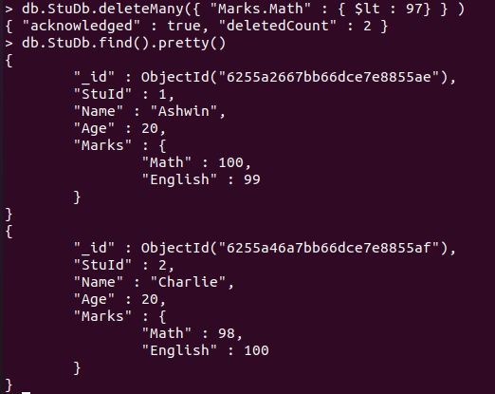



**Result:**

A student management system has been designed using MongoDB and CRUD operations have been performed on it successfully.



**MongoDB Data Replication**

**Exp. No.:** 8 b

**Aim:**

To perform data replication in MongoDB.

**Procedure:**

1. Creating a node in port 27021

mkdir -p $HOME/mongo/data/db01

mongod --replSet dbrs --port 27021 --dbpath $HOME/mongo/data/db01

2. Open another terminal. Create node in a different port, 27022

mkdir -p $HOME/mongo/data/db02

mongod --replSet dbrs --port 27022 --dbpath $HOME/mongo/data/db02

3. In third terminal, create a third node

mkdir -p $HOME/mongo/data/db03

mongod --replSet dbrs --port 27023 --dbpath $HOME/mongo/data/db03

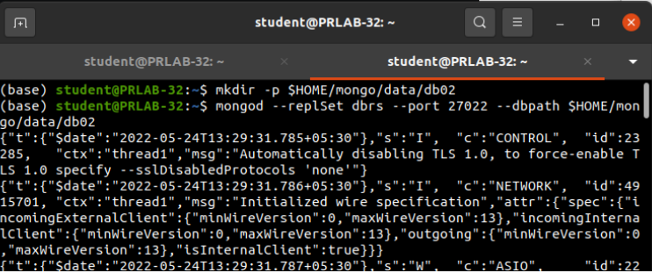

4. Connect to any one Mongo Daemon

mongo --port 27021

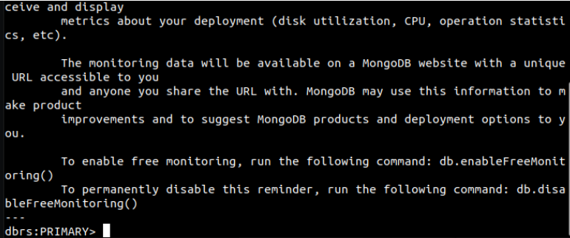

rsconf = {

_id: "dbrs",

members: [

{

_id: 0,

host: "127.0.0.1:27021",

priority: 3

},

{

_id: 1,

host: "127.0.0.1:27022",

priority: 1,

},

{

_id: 2,

host: "127.0.0.1:27023",

priority: 2

}

]

};

db.getMongo().setReadPref('secondary')

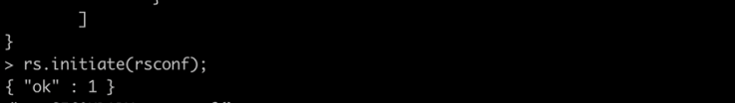



**Result:**

Thus, data replication in MongoDB has been successfully carried out.

**Visualization Tools in Python**

**Exp. No.:** 9

**Aim:**

To study about the visualization tools in python that are used for data analytics.

**Theory:**

1. **Matplotlib**

Matplotlib is a visualization library in Python for 2D plots of arrays. Matplotlib is a multi-platform data visualization library built on NumPy arrays and designed to work with the broader SciPy stack.

Functions in Matplotlib

|  |  |  |
| --- | --- | --- |
| **S. No** | **Function** | **Description** |
| 1. | matplotlib.pyplot.bar(x, height, width=0.8, bottom=None, *, align='center', data=None, **kwargs) | Make a bar plot for two attributes |
| 2. | matplotlib.pyplot.boxplot(x, notch=None) | Make a box and whisker plot |
| 3. | hexbin( ) : matplotlib.pyplot.hexbin(x, y, C=None, gridsize=100, bins=None, xscale='linear', yscale='linear') | Make a 2D hexagonal binning plot of points x, y |
| 4. | matplotlib.pyplot.hist(x, bins=None, range=None, density=None, weights=None) | Plot a histogram |
| 5. | matplotlib.pyplot.pie(x, explode=None, labels=None, colors=None) | Plot a pie chart |
| 6. | matplotlib.pyplot.plot(*args, scalex=True, scaley=True, data=None, **kwargs) | Plot y versus x as lines and/or markers |
| 7. | matplotlib.pyplot.scatter(x, y, s=None, c=None, marker=None, cmap=None, norm=None) | A scatter plot of y vs x with varying marker size and/or color |

1. **Diagram**

Diagrams lets you draw the cloud system architecture in Python code. It was made for prototyping a new system architecture design without any design tools. You can also describe or visualize the existing system architecture as well.

Functions in Diagram

|  |  |  |
| --- | --- | --- |
| **S. No** | **Function** | **Description** |
| 1. | Diagram("Diagram Name") | Create a diagram context with Diagram class |
| 2. | ELB("Node Name") | To perform elastic load balance |
| 3. | Route53("dns") | To establish routing connection |
| 4. | Cluster("Cluster Name") | To create a cluster context |
| 5. | RDS("Node Type") | To create a relational database service instance |
| 6. | SQS("event queue") | To create a simple queue service |
| 7. | Edge(color="*", style="*") | To create an edge between two nodes |

1. **MayaVi**

It is a free, easy to use scientific data visualizer. It is written in Python and uses the amazing Visualization Toolkit (VTK) for the graphics. It provides a GUI written using Tkinter. MayaVi is free and distributed and it is also cross platform.

Functions in MayaVi

|  |  |  |
| --- | --- | --- |
| **S. No** | **Function** | **Description** |
| 1. | barchart(*args, **kwargs) | Plots vertical glyphs (like bars) scaled vertical, to do histogram-like plots. |
| 2. | contour3d(*args, **kwargs) | Plots iso-surfaces for a 3D volume of data supplied as arguments |
| 3. | contour_surf(*args, **kwargs) | Plots the contours of a surface using grid-spaced data for elevation supplied as a 2D array |
| 4. | flow(*args, **kwargs) | Creates a trajectory of particles following the flow of a vector field |
| 5. | imshow(*args, **kwargs) | View a 2D array as an image |
| 6. | mesh(*args, **kwargs) | Plots a surface using grid-spaced data supplied as 2D arrays |
| 7. | plot3d(*args, **kwargs) | Draws lines between points |

1. **Seaborn**

Seaborn is a data visualization library built on top of matplotlib and closely integrated with pandas data structures in Python. Visualization is the central part of Seaborn which helps in exploration and understanding of data.

Functions in Seaborn

|  |  |  |
| --- | --- | --- |
| **S. No** | **Function** | **Description** |
| 1. | seaborn.distplot(x, bins = *, kde = *) | To plot approximate probability density across the y-axis |
| 2. | pie( ) | To plot a pie chart |
| 3. | barh( ) | To plot a bar graph |
| 4. | scatter(x, y) | To plot a scatter plot |
| 5. | jointplot(x, y, kind = ‘reg’) | Creates a regression line between 2 numerical parameters in the jointplot(scatterplot) to help visualize their linear relationships |
| 6. | pairplot(x) | To plot multiple scatter plots at a time |
| 7. | heatmap( ) | To generate a heatmap |

1. **VisPy**

VisPy is a library designed for use by data scientists, and it's intended to make creating complex, interactive visualizations as quickly as possible. VisPy takes advantage of the extra processing power granted by GPUs. This makes the rendering of large datasets faster than other libraries. VisPy graphs and charts can be scaled up, making visualizations out of thousands or even millions of points of data.

Functions in VisPy

|  |  |  |
| --- | --- | --- |
| **S. No** | **Function** | **Description** |
| 1. | vispy.color.BaseColormap(colors=None) | Class representing a colormap |
| 2. | texture_lut() | Return a texture2D object for LUT after its value is set. Can be None |
| 3. | vispy.geometry.MeshData( ) | Class for storing and operating on 3D mesh data |
| 4. | vispy.geometry.curves.curve3_bezier(p1, p2, p3) | Generate the vertices for a quadratic Bezier curve |
| 5. | vispy.io.imread(filename, format=None) | Read image data from disk |
| 6. | vispy.io.imsave(filename, im, format=None) | Save image data to disk |
| 7. | vispy.plot.fig.Fig( ) | Create a figure window |

1. **PyQtGraph**

PyQtGraph is a pure-python graphics and GUI library built on PyQt / PySide and numpy. It is intended for use in mathematics / scientific / engineering applications. Despite being written entirely in python, the library is very fast due to its heavy leverage of NumPy for number crunching and Qt's GraphicsView framework for fast display.

Functions in PyQtGraph

|  |  |  |
| --- | --- | --- |
| **S. No** | **Function** | **Description** |
| 1. | pyqtgraph.plot( ) | Create a new plot window showing data |
| 2. | PlotWidget.plot( ) | Add a new set of data to an existing plot widget |
| 3. | GraphicsLayout.addPlot( ) | Add a new plot to a grid of plots |
| 4. | pyqtgraph.image( ) | To display 2D or 3D data |
| 5. | pyqtgraph.opengl.GLViewWidget() | To create a widget to display 3D objects |
| 6. | pyqtgraph.opengl.GLGridItem() | To create a grid |
| 7. | mkPen( ) | To build a pen with desired configurations |

1. **Chartify**

Chartify is an open-source data visualization library from Spotify that makes it easy for data analysts to create charts and graphs. Chartify is built on top of Bokeh, which is a very popular data visualization library.

Functions in Chartify

|  |  |  |
| --- | --- | --- |
| **S. No** | **Function** | **Description** |
| 1. | chartify.Chart( ) | create a basic chart |
| 2. | chartify.Chart(x_axis_type='datetime') | To set the datatype of the x-axis |
| 3. | set_title( ) | To set the title of the chart |
| 4. | set_subtitle( ) | To set the subtitle of the chart |
| 5. | axes.set_xaxis_label( ) | To set the label of the x-axis |
| 6. | plot.scatter(dataframe, x_col, y_col, color_col) | To draw a scatter plot |
| 7. | plot.histogram(data_frame, values_column) | To draw a histogram |

**Result:**

Thus, a study on the visualization tools in Python used for data analysis has been made.